
Hormel Foods Corporation (Hormel)
Identity Management Foundation
Design Document

Contents
Version Control 8
Revision History 8
Review History 8
Approval History 9
Abbreviation 9
1 Introduction 11
1.1 Executive Summary 11
1.2 Design Principles 11
1.2.1 Establish IAM as a service 11
1.2.2 Secure by default 11
1.2.3 Provide resilience 11
1.2.4 Optimize processes 11
1.2.5 Prioritize user experience 11
1.2.6 Adopt best practices 11
1.3 Design Layers 12
1.3.1 Conceptual Design 12
1.3.2 Logical Design 12
1.3.3 Physical Design 12
1.3.4 Operations Design 12
1.4 Open Items <TBD> 12
1.5 Assumptions <TBD> 13
1.6 Intended Audience 13
2 Saviynt Security Manager Overview 14
2.1 Saviynt Identity Manager 14
2.2 SSM Connectors 14
3 Conceptual Design 16
3.1 Actors / Personas 16
3.2 Conceptual Solution 17
3.3 User Experience 19
3.3.1 Access Requester Experience 19
3.3.2 Approver Experience 21
3.3.3 Remove Access Experience 23
3.3.4 Landing Page Shortcuts 27
3.3.5 Personalization 28
4 Logical Design 29
4.1 Naming Conventions 29
4.2 Applications 29
4.3 Identity Use Case Design 30
4.3.1 User Types 30
4.3.2 User Profile Fields 30
4.3.3 Possible Value List from HCM 33
4.3.4 Identity On-boarding (Trusted Source Reconciliation) 33
4.4 Active Directory Connector Design 44
4.4.1 User Account Correlation Rule 44
4.4.2 Provisioning Attribute Mapping 45
4.4.3 Reconciliation Attribute Mapping 46
4.4.4 Active Directory Account Creation 48
4.4.5 Active Directory Account Modification 49
4.4.6 Active Directory Account Disable 50
4.4.7 Active Directory Account Deletion 51
4.4.8 Active Directory Account Rehire 52
4.4.9 Active Directory Add Group 53
4.4.10 Active Directory Remove Group 54
4.5 Mailbox Connector Design 55
4.5.1 User Account Correlation Rule 55
4.5.2 Provisioning Attribute Mapping 56
4.5.3 Reconciliation Attribute Mapping 56
4.5.4 Mailbox Account Creation 56
4.5.5 Mailbox Account Disable/Deletion 57
4.6 Oracle HCM identity Update 58
4.7 Approval Workflows 59
4.8 Birth Right Rules 60
4.8.1 Birth Right Rules Design 60
4.8.2 Birth right Rules List 60
4.9 Business Rules 62
4.10 Scheduled Tasks 63
5 Physical Design 65
5.1 Physical Architecture Overview 65
5.1.1 Development Environment 65
5.1.2 Production Environment 66
5.1.3 Environment Mapping with Connected Systems 67
5.2 Hardware Components 68
5.2.1 Server Pre-requisites 68
5.2.2 Hardware Components 69
5.2.3 High Availability 69
6 Operations Design 71
6.1 Security 71
6.1.1 Authentication 71
6.1.2 Saviynt Operational Roles 71
6.1.3 Role Governance 72
6.2 Deployment Methodology 72
6.3 Backup and Recovery 72
6.3.1 DR Terminology 72
6.3.2 High-Level Backup and Archival Strategy 73
6.4 Patch and Upgrades 73
6.5 Health check monitoring 73
6.6 Logging 73
6.7 Certificates 74
6.8 NTP Setup 74
6.8.1 Saviynt Cloud NTP 74
6.9 Reports 74
7 Requirements Traceability Matrix 75
8 Design Challenges and Decisions 77
9 Appendix 80
9.1 Key Terminologies 80
9.2 Notifications 80
9.2.1 N01# Active Directory User Account Creation 81
9.2.2 N02# Active Directory User Account Disable 81
9.2.3 N03# Active Directory User Account Enable 82
9.2.4 N04# Active Directory User Account Deleted 82
9.2.5 N05# Active Directory User Account Creation For Security Techs Team 83
9.2.6 N06# Mailbox User Account Creation 84
9.2.7 N07# Mailbox User Account Creation For Mailbox Team 84
9.2.8 N08# Mailbox User Account Disabled 85
9.2.9 N09# Access Request Assignment Email Notification 86
9.2.10 N10# Access Request Reminder Email Notification 86
9.2.11 N11# Access Request Reassignment Email Notification 87
9.2.12 N12# Access Request Approved Email Notification 88
9.2.13 N13# Access Request Rejected Email Notification 88
9.2.14 N14# Access Request Expired Email Notification 89
9.2.15 N15# Account Request Assignment Email Notification 90
9.2.16 N16# Account Request Reminder Email Notification 90
9.2.17 N17# Account Request Reassignment Email Notification 91
9.2.18 N18# Account Request Approved Email Notification 92
9.2.19 N19# Account Request Rejected Email Notification 92
9.2.20 N20# Account Request Expired Email Notification 93
9.2.21 N21# Active Directory Account Deleted Today Report 93
9.2.22 N22# Active Directory Account Deletion in Next 24 hrs 94
9.2.23 N23# Active Directory Group Removal Report 94
9.2.24 N24# Invalid Domain Email Address Report 95
9.2.25 N25# Reconciliation Job Failure Report 95
9.2.26 N26# Active Directory Task Failure Report 96
9.2.27 N27# Mailbox Task Failure Report 96

Table of Tables
Table 1: Open Items 12
Table 2: Assumptions 13
Table 3: SSM Connector. 14
Table 4: Actors/Personas 16
Table 5: Key Components 18
Table 6: Landing Page Shortcuts 27
Table 7: Naming Convention 29
Table 8: Application List 29
Table 9 : Saviynt User Attribute Fields and Labels 31
Table 10: HCM Possible Value List 33
Table 11 : Transformation 34
Table 12 : Atom Feed Collections 35
Table 13 : Transformation - Atom Feed 37
Table 14: Oracle HCM for Location API Mapping with SSM 38
Table 15: Oracle HCM for Location API Mapping with User profile 39
Table 16: Oracle HCM for Job API Mapping with SSM 40
Table 17: Oracle HCM for Job API Mapping with User profile 40
Table 18: Oracle HCM for Country API Mapping with SSM 40
Table 19: Oracle HCM for Country API Mapping with User profile 41
Table 20 : User Manager Reconciliation 41
Table 21: HCM Correlation Rule 41
Table 22: Reconciliation Attribute Mapping 42
Table 23 : Identity Use Case Flow 44
Table 24 : Active Directory Correlation Rule 44
Table 25 : AD Provisioning Attribute Mapping 45
Table 26 : AD Reconciliation Attribute Mapping 46
Table 27 : Active Directory Correlation Rule 55
Table 28 : Mailbox Provisioning Attribute Mapping 56
Table 29 : Mailbox Reconciliation Attribute Mapping 56
Table 30: Oracle HCM Mapping for Data Update 59
Table 31: Approval Process and Level 59
Table 32: Update Detective User Rule 60
Table 33: Birth Right Rule 60
Table 34: Business Rule 62
Table 35: Scheduled Task 63
Table 36: Environment Mapping with Connected System 68
Table 37: DEV Environment Details 68
Table 38: UAT Environment Details 68
Table 39: PROD Environment Details 69
Table 40: Server Pre-Requisites 69
Table 41: DEV Hardware Component 69
Table 42: UAT Hardware Component 70
Table 43: PROD Hardware Component 70
Table 44: High Availability 70
Table 45: Authentication 71
Table 46: Saviynt Operational Roles 71
Table 47 : DR Terminology 73
Table 48: Patch and Upgrade 73
Table 49: Health Check Monitoring 73
Table 50: Saviynt Analytics Report 74
Table 51: Requirement Traceability Matrix 75
Table 52: Design Challenges and Decision 77
Table 53: Key Terminologies 80
Table 54: Active Directory User Account Creation 81
Table 55: Active Directory User Account Disable 81
Table 56: Active Directory User Account Enable 82
Table 57: Active Directory User Account Deleted 82
Table 58: Active Directory User Account Creation For Security Techs Team 83
Table 59: Mailbox User Account Creation 84
Table 60: Mailbox User Account Creation For Mailbox Team 84
Table 61: Mailbox User Account Disabled 85
Table 62: Access Request Assignment Email Notification 86
Table 63: Access Request Reminder Email Notification 86
Table 64: Access Request Reassignment Email Notification 87
Table 65: Access Request Approved Email Notification 88
Table 66: Access Request Rejected Email Notification 88
Table 67: Access Request Expired Email Notification 89
Table 68: Account Request Assignment Email Notification 90
Table 69: Account Request Reminder Email Notification 90
Table 70: Account Request Reassignment Email Notification 91
Table 71: Account Request Approved Email Notification 92
Table 72: Account Request Rejected Email Notification 92
Table 73: Account Request Expired Email Notification 93
Table 74: Active Directory Account Deleted Today Report 93
Table 75: Active Directory Account Deletion in Next 24 hrs 94
Table 76: Active Directory Group Removal Report 94
Table 77: Invalid Domain Email Address Report 95
Table 78: Reconciliation Job Failure Report 95
Table 79: Active Directory Task Failure Report 96
Table 80: Mailbox Task Failure Report 96

Table of Figures
Figure 1: Saviynt Cloud Access Governance and Intelligence 14
Figure 2: IDM Architecture 17
Figure 3: Request Access for Others 19
Figure 4: User Search 19
Figure 5: Add to Cart 20
Figure 6: Select Access 20
Figure 7: Add Business Justification 21
Figure 8: Request Approval (tile or tab) 21
Figure 9: User Request ID 22
Figure 10: Accept/Reject Request 22
Figure 11: Add Comment and Submit 23
Figure 12: Confirm Request 23
Figure 13: Request Completed 23
Figure 14: Remove Access - User Login 24
Figure 15: Remove Access – ARS 24
Figure 16: Remove Access – Request Access for Others 25
Figure 17: Remove Access – Search Users 25
Figure 18: Remove Access from Cart 26
Figure 19: Remove Account 26
Figure 20: Remove Access – Submit 26
Figure 21: Logo on Application Screen 28
Figure 22: Full Reconciliation - Employee Process 34
Figure 23 : Incremental User Reconciliation 36
Figure 24 : Existing Contingent Worker Onboarding 38
Figure 25: AD Account Creation 49
Figure 26: AD Account Modification 50
Figure 27: AD Account Disable 51
Figure 28: AD Account Deletion 52
Figure 29: AD Account Rehire 53
Figure 30: AD Add Group 54
Figure 31: AD Remove Group 55
Figure 32: Mailbox Account Creation 57
Figure 33: Mailbox Account Disable/Deletion 58
Figure 34: DEV Physical Architecture 66
Figure 35: PROD Physical Architecture 67

Version Control

Revision History
This section represents the change history of the document. All revisions of the document must be tracked by identifying a new version number, the date it was modified, the person making the change, and the reason for the change.
Version | Date | Author | Comments
0.1 | 11/10/2020 | Anjali Patil/Ajinkya Chavan
1.0 | 11/14/2020 | Anjali Patil/Ajinkya Chavan | Update section 7 of the document
1.1 | 11/18/2020 | Anjali Patil/Ajinkya Chavan | Update the approval workflows
1.2 | 11/20/2020 | Anjali Patil/Ajinkya Chavan | Updated architecture as per new design
1.3 | 11/23/2020 | Anjali Patil/Ajinkya Chavan | Updated notifications
1.4 | 11/24/2020 | Anjali Patil/Ajinkya Chavan | Addressed comments
1.5 | 12/05/2020 | Anjali Patil/Ajinkya Chavan | Addressed comments from Wesley Rowden
1.6 | 12/10/2020 | Anjali Patil/Ajinkya Chavan | Updated changes in few configurations
1.7 | 12/18/2020 | Anjali Patil/Ajinkya Chavan | Addressed comments from Tony Bowe

Review History
Version | Reviewed By | Date
1.3 | Sai Mulam | 11/18/2020
1.4 | Sai Mulam | 11/30/2020
1.4 | Hormel Team | 12/04/2020
1.7 | Sai Mulam | 12/22/2020

Approval History
The signing of this document acknowledges everyone’s concurrence with the validity and accuracy of the information contained in this document.
Version | Approved By | Date

Abbreviation
Abbreviation | Terms | Description
SSM | Saviynt Security Manager | Saviynt’s identity management product name
IAM | Identity Access Management | IAM refers to a framework of policies and technologies for ensuring that the people in an enterprise have the appropriate access to technology resources
DN | Distinguished Name | Every entry in the directory has a distinguished name (DN). DN is the name that uniquely identifies an entry in the directory. The first component of the DN is referred to as the Relative Distinguished Name (RDN).
OU | Organizational Unit | An organizational unit (OU) is a subdivision within an Active Directory into which you can place users, groups, computers, and other organizational units
HTTP | Hypertext Transfer Protocol | An application protocol for distributed, collaborative, and hypermedia information systems.
HTTPS | Hypertext Transfer Protocol Secure | An application protocol for distributed, collaborative, and hypermedia information systems through an encrypted channel.
SSL | Secure Sockets Layer | Standard security technology for establishing an encrypted link between a server and a client.
OOTB | Out-of-the-Box | Standard/default configuration that doesn’t require any special customization
TCP | Transmission Control Protocol | The Transmission Control Protocol is one of the main protocols of the Internet protocol suite. It originated in the initial network implementation in which it complemented the Internet Protocol.
LDAP | Lightweight Directory Access Protocol | The Lightweight Directory Access Protocol is an open, vendor-neutral, industry-standard application protocol for accessing and maintaining distributed directory information services over an Internet Protocol network

Introduction

Executive Summary
Hormel Foods Corporation (Hormel) has embarked upon a technology-driven transformation initiative for its Identity and Access Management (IAM) program called Access Central. The key objective of this initiative is to implement Saviynt Identity Management as the strategic technology solution that will be used to automate enterprise user’s lifecycle and access management across key systems.
The purpose of this document is to define the logical, physical, and operational architectures as well as the design details, decisions, and approaches that are taken for implementing the solution. This document details the solution design across all environments: DEV, UAT and PROD. This document should be considered as the sole extensive design resource that is the foundation for all environments and IAM solution builds, superseding all other documentation (if any).
The scope of the user base that will be affected by this change is limited to systems like Active Directory and Mailbox.

Design Principles
The IAM team will be guided by the following principles for all design decisions and approaches covered in this design document.

Establish IAM as a service
Provide IAM as a service and promote re-usability, granularity, modularity, loose coupling and interoperability in solution design. Enterprise applications leverage IAM infrastructure to assess the “rights and privileges” of a user or application and then provide access accordingly.

Secure by default
Features and data can only be accessed when access has been explicitly assigned and are protected from unintended or unauthorized access, change or destruction by leveraging the principle of least privilege. This includes protection from unplanned events and natural disasters. The solution defaults to a secure version of the transport protocol for information transfer and will encrypt all information while it is at rest.

Provide resilience
IAM infrastructure will be implemented such that there is no single point of failure and provides services exceeding the standard expected load to ensure the availability of integrated applications.

Optimize processes
Reduce manual processes as they can be error-prone, may introduce new risks and is costly to maintain. Redesign existing processes to embrace simplicity and reduce complexity. Encourage automation wherever it is practical and cost-efficient.

Prioritize user experience
Implement usable security. Security must not discourage users from using information systems. Instead, security should complement the user experience.

Adopt best practices
Adopt industry best practices and standards while implementing security standards. Security threats are ever-evolving and so are security standards safeguarding against them.

Design Layers
The presentation of this design document has been structured into four main aspects: Conceptual Design, Logical Design, Physical Design, and Operations Design, each going into more details from conceptual ideation to physical implementation and sustenance considerations. In addition, the document also details the reason for specific implementation approaches wherever design challenges were identified.

Conceptual Design
Conceptual Design captures a big-picture vision of the whole solution. This design identifies the major functional components needed to provide the core business/mission capabilities within the solution, describes the relationship to the various organizations interacting with the solution’s building blocks, the purpose of each building block component, and the interrelationships among the functional components.

Logical Design
Logical Design describes these software components and the information and control flows among the components within the system. It results from allocating the functional components in the logical design to software components identified from requirements analysis and early design work.

Physical Design
Physical Design describes the mapping of all software components to hardware components and detailed information and control flows. It includes connections to internal and external networks; incorporation of security features and devices, component integration mechanisms, and component scaling mechanisms needed to meet non-functional requirements.

Operations Design
Operations Design describes support for various capabilities required for sustenance of the system before, during and after go-live. This includes security, deployment, upgrade and patching, backup and recovery, logging, health check, and reports

Open Items <TBD>
Table 1: Open Items
# | Name | Description | Status | Owner | Last Updated
1 | Mailbox Integration | Reconciliation of mailbox accounts is still open | Open | Anjali | 11/18/2020
2
3
4

Assumptions <TBD>
Table 2: Assumptions
# | Assumption
 | Oracle HCM is the authoritative source for “Employees” and “Contingent Worker” identities.
 | Saviynt has limitation that it cannot parse and send a new line character to Active Directory while provisioning. The same was informed to Hormel team and was agreed that the streetAddress will be populated with a comma separator than a new line. The external script will replace the comma with new line which will be handled outside Saviynt.
 | GL attributes are not available for Saviynt to fetch from HCM through API. The external script will populate this attribute in Active Directory.
 | Active Directory group request will always go to Group owner for approval in Saviynt.

Intended Audience
- The primary audience for this document is the enterprise architects and business process owners at Hormel who are responsible for maintenance and sustenance of Identity and Access Management processes, automation, and security.
- This document will be referred by the development team to implement and deliver the solution.
- Additionally, the document should be reviewed by Application Owners and Technical Architects of the downstream (Active Directory, Oracle HCM for AD attribute updates and Mailbox) and upstream systems (Oracle HCM).
- The document lays out specific details regarding hardware and networking requirements, which should be reviewed by Hormel’s network and infrastructure teams.

Saviynt Security Manager Overview
Saviynt is a cloud-native Identity Governance and Administration (IGA) platform that protects an organization's most sensitive information and increases your organizational efficiency and agility by ensuring that the right people have the right access to the right resources for only the right amount of time.
It is a leading provider of Cloud Security and Identity Governance solution that provides a single platform to secure applications, data in Cloud (E.g.: Office 365, AWS, Azure, Salesforce, Workday) and On-premises (E.g.: SAP, Oracle EBS) systems.
Saviynt’s platform unifies accounts across the ecosystem, creating one identity with fine-grained entitlements for each user. Saviynt automates account and access provisioning aligned with organizational risk tolerance and workflows so organizations can reduce human error risk, accelerate onboarding, and holistically view all users’ access.
Figure 1: Saviynt Cloud Access Governance and Intelligence
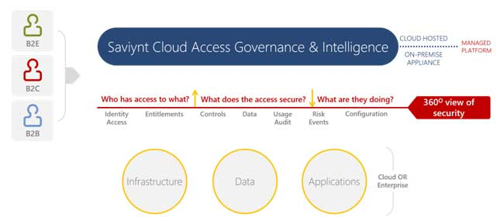
The following are the key components of the Saviynt Security Manager that would be used as part of this design.

Saviynt Identity Manager
Saviynt Identity Manager provides user access provisioning, de-provisioning, and Identity Governance and Administration (IGA) capabilities for an organization. It has a cloud-hosted web application that supports self-service and administration capabilities. This component also supports Identity Management for Developers to configure processes and customizations.

SSM Connectors
The following connectors, provided by SSM, will be configured for setting up integrations with various systems that are part of the scope.
Table 3: SSM Connector.
Connector | Application | Description
Active Directory (AD) Connector | Active Directory | Active Directory Connector supports user and group management capabilities, including OU changes on account enable that are part of Hormel’s requirements.
REST Connector | Oracle HCM/Mailbox | REST Connector supports REST API standards-based integration with systems. It can be used for both upstream or downstream systems. This connector would be used to support integration with Oracle HCM and Mailbox.

Conceptual Design

Actors / Personas
Table 4: Actors/Personas
End-User | End-Users are employees/contingent workers within Hormel.
Manager | The manager is an end user's manager as per the organizational hierarchy at Hormel. The source of this information is Oracle HCM for all the end users.
Entitlement Owner | Active Directory – Designated personnel responsible for approving the specific groups.
IAM Administrator | IAM Administrator is considered as ‘superusers’ within Saviynt and has administrative abilities to manage users, accounts, roles, and configurations within Saviynt. These users have a specific Saviynt Role: ROLE_ADMIN.
Human Resources | Human resources or HR is the department charged with onboarding the employees in Oracle HCM.
Helpdesk | Helpdesk group who is responsible for change password in Active Directory if users contact for change password.

Note: Saviynt provides the capability to create “SAV Roles” which allow the administrator to restrict the user’s capabilities within the Saviynt UI. More details are provided in Section 6.1.2.

Conceptual Solution
This section details the IAM Solution Architecture for Identity Management.
Figure 2: IDM Architecture
As shown in the diagram above, Saviynt will provide a centralized platform to support identity and access management capabilities, including identity lifecycle and account management for key systems like Active Directory, and Mailbox. Once deployed, Saviynt will control the provisioning, modification (user profile and location updates) and de-provisioning of users in the downstream applications. Saviynt will synchronize user identities from Oracle HCM for Employees and Other users. Saviynt will simplify user onboarding by automating provisioning of ‘pre-approved’ access as birth rights based on user’s Location and People Group. Additionally, end users will use Saviynt to raise requests for access to applications.
Table 5: Key Components
Component | Description
SSM | SSM represents the SaaS-based application that is deployed on a public cloud by Saviynt. It is exposed to the enterprise as a web application.  This is the centralized IDM system which will facilitate automated identity onboarding, provisioning, de-provisioning, access request, certifications, and reconciliation functions in the enterprise.
Express Route | SSM uses the express route service that is offered by Azure to route the traffic from Saviynt virtual network to Hormel virtual network.
Oracle HCM | This application is the authoritative source for Employees and Contingent Workers. SSM will connect to Oracle HCM using REST connector to fetch employee and Contingent Worker’s records into SSM. For initial load we will use the file feed exported from Active Directory and Oracle HCM to load user data in to Saviynt.
Active Directory | Microsoft Active Directory is a key directory services technology across Hormel. As a part of the initial (or Day 0) load, existing users’ identity will be reconciled into SSM from AD to populate the existing SamAccountName into Saviynt as Saviynt user name. Active Directory would become one of the downstream systems for SSM post go-live.
Mailbox | To provision the Mailbox account, PowerShell script will be executed on Windows Connect Server to create a mailbox account for the user on Exchange Server.

User Experience
This section details the user experience of various Actors when they interact with the SSM web interface while performing various activities that are part of the scope of this design. It is noted that SSM, being a SaaS solution, provides only limited capabilities to customize user experience and the solution design is limited to customizations that are supported on the platform.

Access Requester Experience
In the enterprise, the IDM solution provides a centralized platform for access requests. SSM’s access request system is leveraged for request workflow. SSM enables users to raise access requests for following types of access:
- Application Accounts
- Application Entitlements
The following steps provide additional details on the user experience of a typical request for Application. Note that depending upon request and details provided, the user experience may differ.

Step 1: Users log in to Saviynt Security Manager using their credentials and click on Request Access for others tile on ARS page.
Figure 3: Request Access for Others
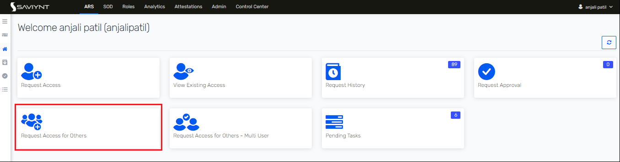
Step 2: Users search the appropriate beneficiary from the User List and click on the Next button.
Figure 4: User Search
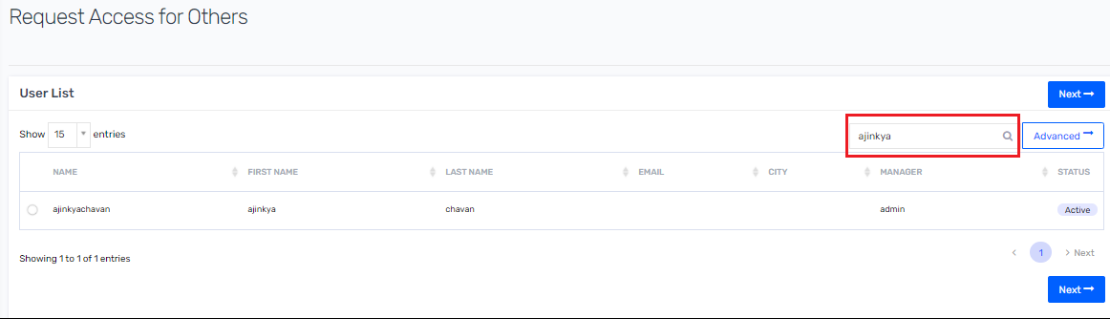
Step 3: Users select the appropriate application to add to the cart and click on the Checkout button.
Figure 5: Add to Cart
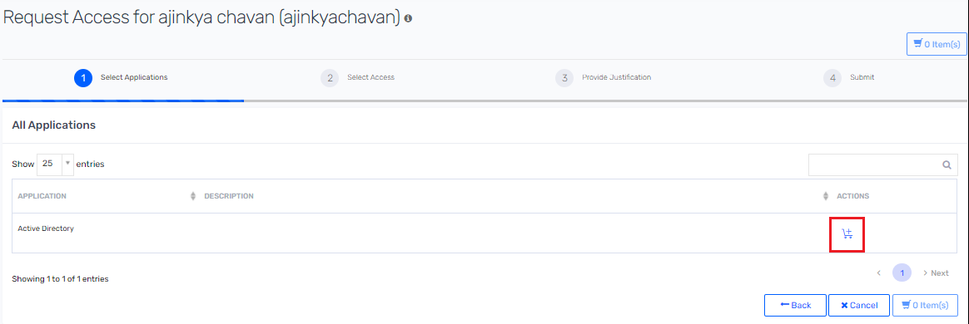
Step 4: Users select the appropriate access detail and click on the Next button.
Figure 6: Select Access
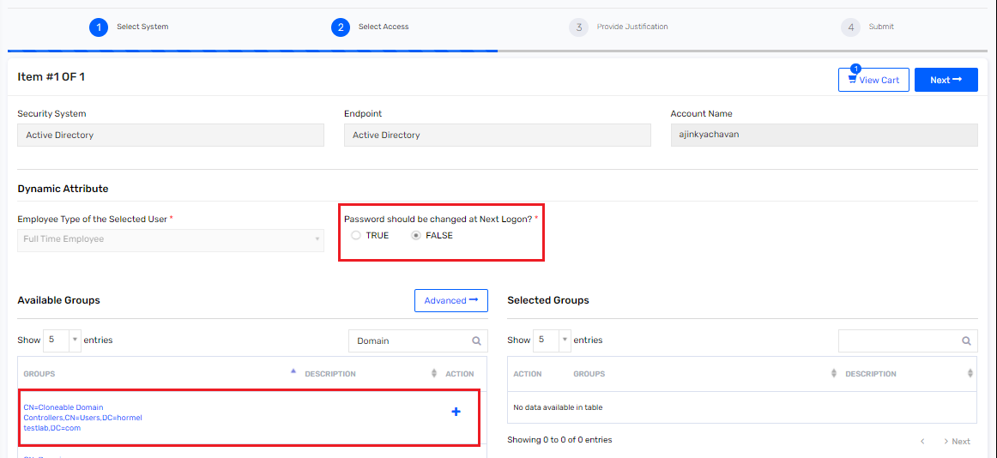
Step 5: Add the Business Justification and Comments then submit the request. Note that these are comments required for the approver to understand the need of request and approve it.
Figure 7: Add Business Justification
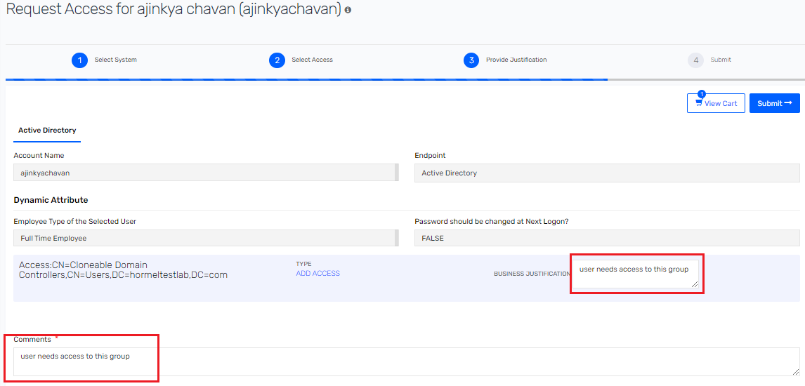

Approver Experience
Step 1: Approver receives an email-based notification once the request is assigned to him/her. Refer to Section 9.2 for details.
Step 2: Approver Logs on to Saviynt and clicks on Request Approval tile or Request Approval tab on the left pane from ARS tab.
Figure 8: Request Approval (tile or tab)
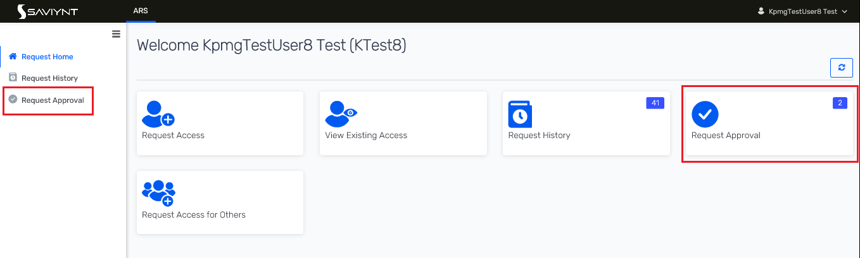
Step 3: Select the Request ID to view the request details.
Figure 9: User Request ID
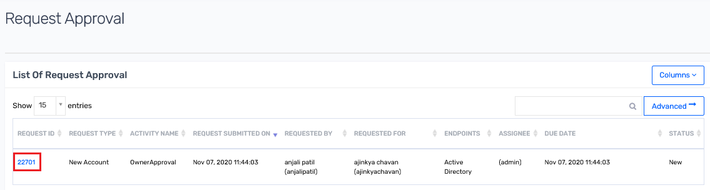

Step 4: View the details of the request and select on Accept or Reject access detail. Note that the Approver will have the ability to “partially” approve a request. By partial approval, approver must make sure that “New Account” is approved to approve at least one “ACCESS” for a request that has account and access request for an endpoint.

Figure 10: Accept/Reject Request
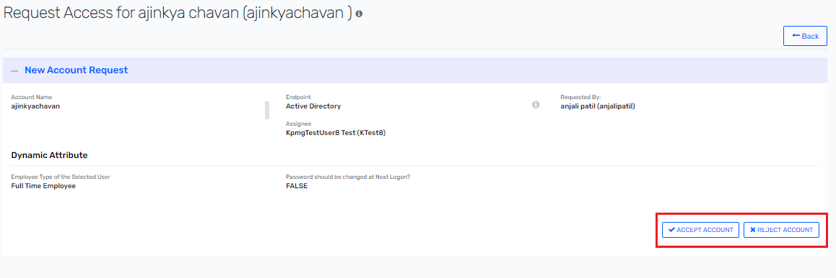

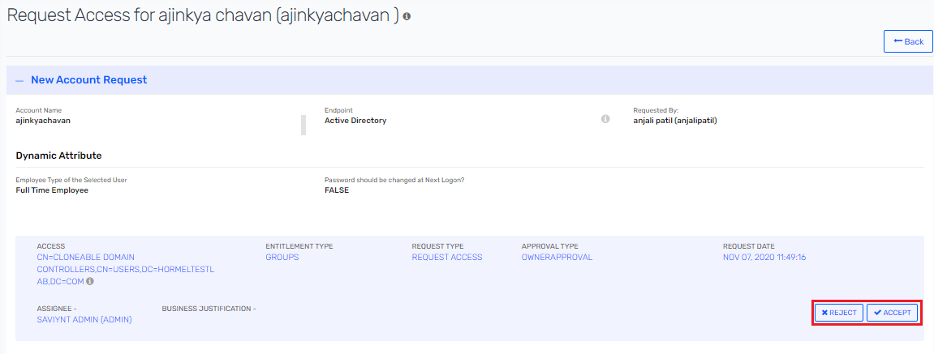

Step 5: Enter the comment and click on submit.
Figure 11: Add Comment and Submit
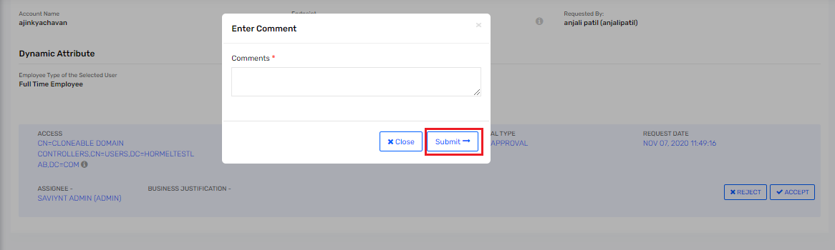

Step 6: Approver confirm the request by clicking on the Confirm button.
Figure 12: Confirm Request
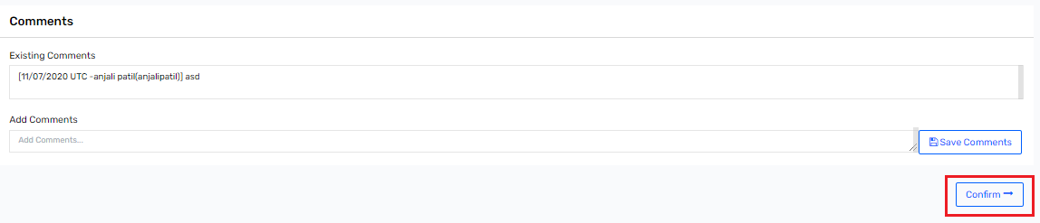

Step 7: Once the request is confirmed, a message will pop on top right of screen as Request completed.
Figure 13: Request Completed
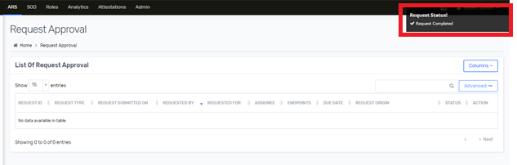

Remove Access Experience
End users can remove their access, while Managers can remove their active reportee's access and IAM Administrators can remove any active user account access at any point in time.
Step 1: Users log in to Saviynt Security Manager using their credentials.
Figure 14: Remove Access - User Login
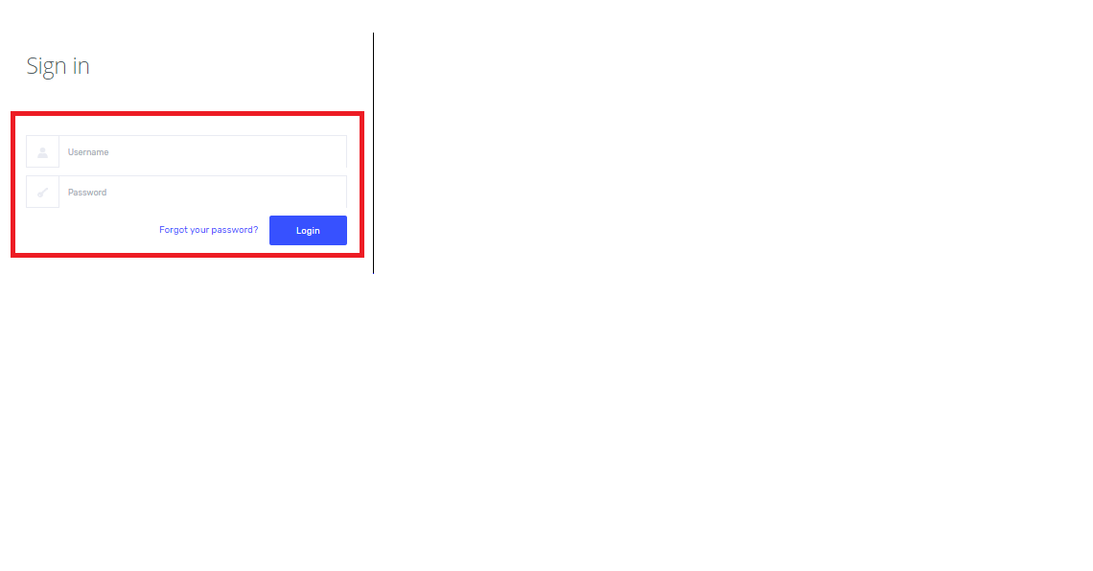
Step 2: Click on the ARS dashboard.
Figure 15: Remove Access – ARS
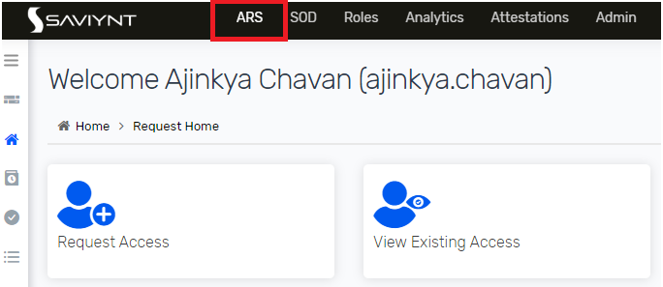

Step 3: Click on Request Access for Others title from the ARS tab.
Figure 16: Remove Access – Request Access for Others
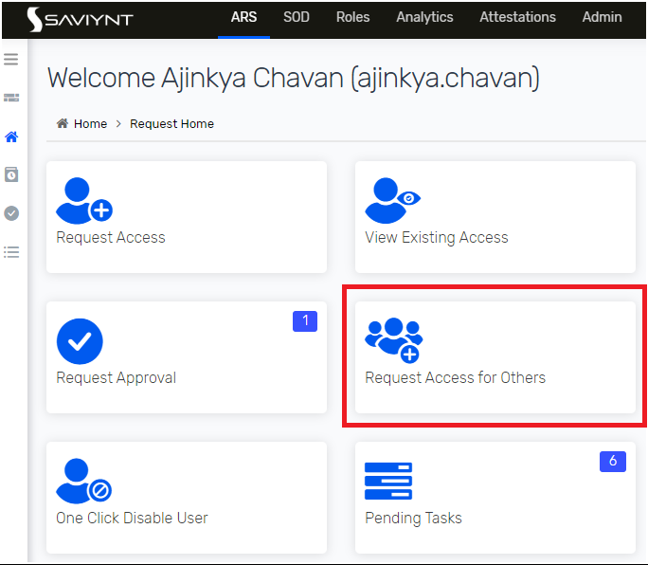
Step 4: Search the appropriate beneficiary from the User List and click on the Next button.
Figure 17: Remove Access – Search Users
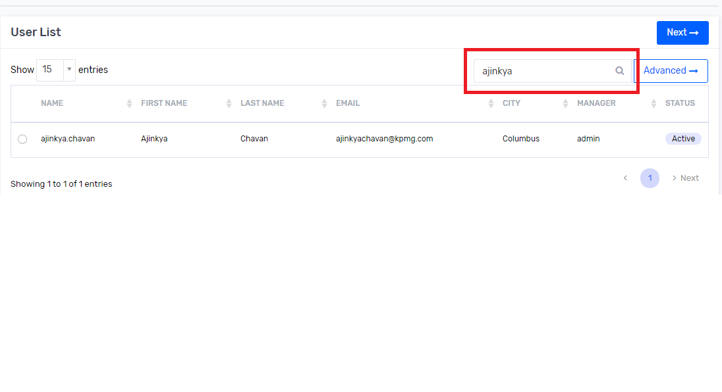
Step 5: Click on the [X] to remove individual access.
Figure 18: Remove Access from Cart
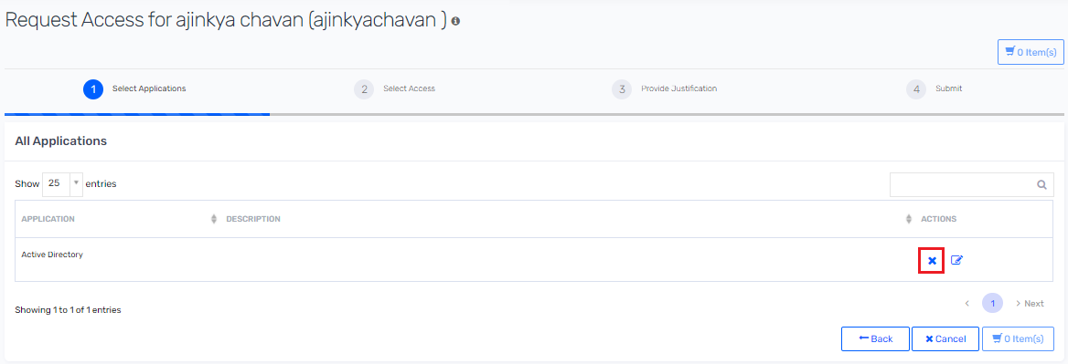
Step 6: Click on the Remove button, if prompted.
Figure 19: Remove Account
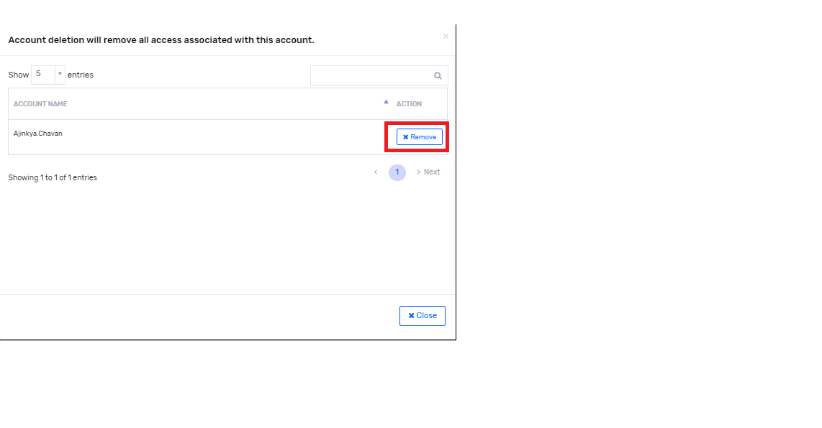

Step 7: Provide the comments then click submit to complete the remove access request.
Figure 20: Remove Access – Submit

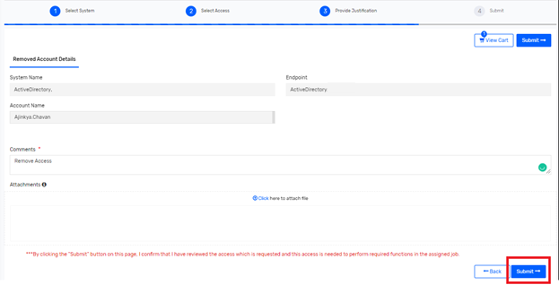

Landing Page Shortcuts
Saviynt supports customizations to bring shortcuts to the landing page of users for easy access. The following shortcuts will be created for various actors.
Table 6: Landing Page Shortcuts
Actor | End-User  (ROLE_HORMEL_ENDUSER) | Security Techs Admin  (ROLE_HORMEL_ADMIN) | IAM Admin  (ROLE_ADMIN) | Helpdesk  (ROLE_HORMEL_HELPDESK)
Request Access
View Existing Access
Request History
Request Approval
Change Password
Request Access for Others
Pending Task

Personalization
SSM will be configured to provide a customized look and feel for the enterprise users. The OOTB colour scheme, pages, and text will be changed as per the enterprise needs. The Saviynt UI will include the Hormel logo wherever possible.
Figure 21: Logo on Application Screen
The image used as an organization's logo to be displayed on the application screen must be in .png format with transparent background and must meet the following size specifications:
Height: 29 pixels and Width: 136 pixels

Logical Design

Naming Conventions
Following naming conventions would be used while defining various artefacts within SSM.
Table 7: Naming Convention
Configuration Type | Naming Convention | Sample
Application Names | Generic name of Applications as they are known in Hormel | Active Directory  Mailbox
Workflow Names | Capitalization, the first letter of a word in uppercase, and the rest of the letters in lowercase or called Camel Case. | Account Group Approval Workflow
Custom Attribute Names | Camel Case with no spaces | sampleAttribute
Schedule Task Names | ALL CAPS, all letters in every word are capitalized. | PROVISIONING_JOB  HORMEL_USER_RECON
Application Entitlements | As defined in downstream systems. | NAMEDUSER_NO_RDP

Applications
Following applications will be defined on SSM
Table 8: Application List
Application Name | Description | Provisioning Support | Reconciliation Support | Connector(s)
Oracle HCM | Authoritative source of Employees, and Contingent Workers | Yes. Only WorkEmail | Trusted Reconciliation | REST
Active Directory | Downstream system | Yes | Trusted Reconciliation for User Name for existing users only on Day 0 and Target Reconciliation | AD
Mailbox | Downstream system | Yes | Target Reconciliation | REST
Oracle HCM Country | Application used to reconcile HCM country into Saviynt | No | Target Reconciliation | REST
Oracle HCM Department Name | Application used to reconcile HCM Department name into Saviynt | No | Target Reconciliation | REST
Oracle HCM Jobname | Application used to reconcile HCM Job names into Saviynt | No | Target Reconciliation | REST
Oracle HCM Location | Employee and Worker API of Oracle HCM which are used for authoritative source reconciliation uses location codes and do not have other location details. A separate connection is created in SSM to fetch the location details from location API and update user profiles. | No | Target Reconciliation | REST
Saviynt Security System | Saviynt internal application to provide access to End User SAV role | No | Target Reconciliation | DB

Note: As a reminder, Trusted Reconciliation means that Saviynt will trust the application as a source of identities. Target Reconciliation means that Saviynt will attempt to co-relate accounts from the source with existing identities, and not create a new identity.

Identity Use Case Design
This section describes the design details for the identity data layer in the IDM solution for the enterprise. It captures the authoritative sources for enterprise identities at Hormel, and defines their correlation with the centralized IDM platform, Saviynt.

User Types
Saviynt will hold the following identity types in its repository:
- Full-Time Employee
- Pending Worker
- Contingent Worker

User Profile Fields
Following attribute are Saviynt user profile attribute. Saviynt custom attributes are labelled as per below mention labels mapping table.
Table 9 : Saviynt User Attribute Fields and Labels
Sr No | Field Name | Label
1 | firstName | First Name
2 | lastName | Last Name
3 | middleName | Middle Name
4 | displayName | Display Name
5 | preferredFirstName | Preferred First Name
6 | employeeId | Employee Number
7 | employeeType | Employee Type
8 | employeeClass | Assignment Categories
9 | title | Title
10 | jobcode | Job Code Desc
11 | departmentname | Department Name
12 | locationnumber | Location Number
13 | locationdescription | Location Desc
14 | location | Location
15 | companyname | Company Name
16 | startDate | Start Date
17 | enddate | End Date
18 | statuskey | Status Key
19 | street | Street
20 | city | City
21 | state | State
22 | country | Country
23 | owner | Owner
24 | regioncode | Region Code
25 | customproperty1 | Postal Code
26 | customproperty2 | IT ID (Employee ID)
27 | customproperty3 | Domain
28 | customproperty4 | Email
29 | customproperty5 | UPN
30 | customproperty6 | Person Id
31 | customproperty7 | Manager Assignment ID
32 | customproperty8 | Assignment ID
33 | customproperty9 | Location ID
34 | customproperty10 | Job ID
35 | customproperty11 | Work At Home Flag
36 | customproperty12 | Action Code
37 | customproperty13 | Active Directory OU
38 | customproperty14 | First Name without Special character.
39 | customproperty15 | Last Name without Special character.
40 | customproperty16 | HCM Employee Type
41 | customproperty17 | Extension Attribute 1
42 | customproperty18 | Country Name
43 | customproperty19 | User Person Type
44 | customproperty20 | Working Hours
45 | customproperty21 | Frequency
46 | customproperty22 | No of Days Calculation for Onboarding
47 | customproperty23 | People Group
48 | customproperty24 | Mailbox BR Flag

Possible Value List from HCM
Following are possible values that are present in Oracle HCM system.
Table 10: HCM Possible Value List
Sr No | HCM Attribute Name | Possible Values
1 | Assignment Status Type | - ACTIVE  - INACTIVE
2 | Action Code | - TERMINATION  - HIRE  - REHIRE  - TRANSFER  - JOB_CHANGE
3 | AssignmentCategory | - FR (Full-time regular)  - FT (Full-time temporary)  - PR (Part-time regular)  - PT (Part-time temporary)
4 | WorkerType | - E  - P  - C

Identity On-boarding (Trusted Source Reconciliation)
Oracle HCM will be the authoritative source for employees and contingent workers that are part of Hormel and it will be the only source of truth for their data. In IDM solutions, Saviynt will be integrated directly with this HR system to import user data in periodic interval for creating new user records, updating existing ones, also triggering different lifecycle management events as per updates to keep access to other target applications such as Active Directory and Mailbox in accordance to the access policies defined by the organization.
File base import, REST connector and custom Java code will be configured in Saviynt to reconcile user identities from the Oracle HCM.
Rest connector reconciles user identities from Oracle HCM periodically. It also uses incremental mode to update employee user identities based on the atom feed in Oracle HCM.

Full User Reconciliation Design
For identity full reconciliation, all active user data which is extracted from Oracle HCM application into csv file will be imported into Saviynt from CSV upload functionality.
Full user import from CSV will be done only for initial day zero load and after day zero load, atom feed will be used for incremental reconciliation of user data.
Figure 22: Full Reconciliation - Employee Process

- Hormel team will provide extracted active users in CSV format from Oracle HCM.
- Data transformation is done manually as per full recon transformation section 4.3.4.1.1 and then transformed active user CSV file is imported into Saviynt using CSV user import functionality.

Full User Reconciliation Transformation
Below data transformation is required to be performed manually on extracted active user CVS file from Oracle HCM, before importing into Saviynt.
Table 11 : Transformation
Sr No | HCM Attribute Name | Saviynt Attribute Name | Transformation Value
1 | WorkerType = E | employeeType | Employee
 | WorkerType = P | employeeType | Pending worker
 | WorkerType = C | employeeType | Contingent worker
2 | AssignmentStatusType = ‘ACTIVE’ | statuskey | 1
 | AssignmentStatusType = ‘INACTIVE | statuskey | 0
3 | ProjectedStartDate is not null  and  Hire date is null | startDate | ProjectedStartDate  (Get value of ProjectedStartDate in startdate)
 | Hiredate is not null | startDate | Hiredate  (Get value of Hiredate in startdate)
4 | Assignment Category = FR | employeeclass | Full-time regular
 | Assignment Category = FT | employeeclass | Full-time temporary
 | Assignment Category = PR | employeeclass | Part-time regular
 | Assignment Category = PT | employeeclass | Part-time temporary

Incremental User Reconciliation Design
For identity incremental reconciliation, REST connector will be used. This connector will fetch all employee/contingent worker information from Oracle HCM Atom feed.
Atom feeds enable to keep track of any changes made to feed-enabled resources in Oracle HCM Cloud. For any updates that may be of interest for downstream applications, such as new hires, terminations, employee update and assignment changed, Oracle HCM Cloud publishes Atom feeds. Custom JAVA code deployed on Saviynt applications will be able to read these feeds and take appropriate action.
There are four API’s required to fetch employee information from Oracle HCM Atom feed.
The following table describes the Atom feed collections for the employee workspace and the triggering events for the feeds.
Feeds are triggered only for employee, contingent worker, and pending worker types.
Table 12 : Atom Feed Collections
Sr No | Atom Feed Collection | Triggering Event
1 | newhire | Atom feeds are triggered when:  - An employee is hired (period of service is created).  - A terminated employee is rehired.  - A future-dated new hire is created.
2 | empupdate | Atom feeds are triggered when:  - Name is corrected or updated.  - Address is created, updated, corrected, or deleted.  - Personal details are updated.
3 | empassignment | Atom feeds are triggered when:  - Assignment information is created, updated, corrected, or deleted.  - Manager information is created, updated, corrected, or deleted.
4 | termination | Atom feeds are triggered when an employee is terminated.

Following process shows sequence of Atom feed API’s is called to fetch incremental user information into Saviynt.
Figure 23 : Incremental User Reconciliation
- Saviynt connects to Oracle HCM though REST connector.
- Saviynt will trigger custom JAVA code deployed on Saviynt server.
- Custom JAVA code will execute to fetch all employee/contingent worker person number which are present in Oracle HCM atom feed.
- Once all records are fetched that are present in Oracle HCM atom feed. Then individual employee and worker API’s of Oracle HCM is called to get all details of employee.
- Custom JAVA code is used to fetch latest updated records and data transformation is done based on business logic, to identify Employee Active Assignment, Employee Type and Hire date etc.
- Once custom JAVA code is executed, then user gets created or updated into Saviynt with transformed data.
- Once Atom feed job is completed then Location, Job, Country and Manager job is executed.
- To calculate user’s manager based on “ManagerAssignmentId”, location detail based on “Location ID” and Job detail based on “Job ID”, other Saviynt jobs will be run and that will update the user profile with respective data.

Incremental User Reconciliation Transformation – Atom Feed

Following table describes transformation that are handled in custom Java code.
Table 13 : Transformation - Atom Feed
Sr No | HCM Attribute Name | Saviynt Attribute Name | Transformation Value
1 | WorkerType = E | employeeType | Employee
 | WorkerType = P | employeeType | Pending worker
 | WorkerType = C | employeeType | Contingent worker
2 | AssignmentStatusType = ‘ACTIVE’ | statuskey | 1
 | AssignmentStatusType = ‘INACTIVE | statuskey | 0
3 | ProjectedStartDate is not null  and  Hire date is null | startDate | ProjectedStartDate  (Get value of ProjectedStartDate in startdate)
 | Hiredate is not null | startDate | Hiredate  (Get value of Hiredate in startdate)
4 | Assignment Category = FR | employeeclass | Full-time regular
 | Assignment Category = FT | employeeclass | Full-time temporary
 | Assignment Category = PR | employeeclass | Part-time regular
 | Assignment Category = PT | employeeclass | Part-time temporary

Onboard existing contingent worker into Oracle HCM and Saviynt.
Following step are required to perform to onboard existing contingent worker in Oracle HCM which are currently not present in Oracle HCM and manually update their employee id into Saviynt.
Figure 24 : Existing Contingent Worker Onboarding
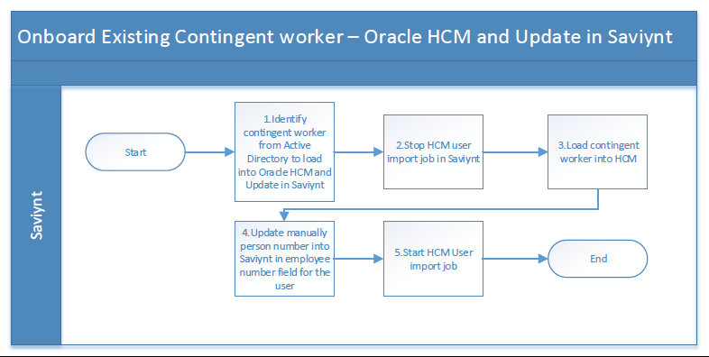
- Identify contingent worker that needs to onboard into Oracle HCM.
- Before identity is onboarded into Oracle HCM, Saviynt user import job needs to be stop.
- Then load contingent worker into Oracle HCM.
- Manually update person number into Saviynt in employee id field and then start user import job
- After Saviynt user import is ran, then newly created contingent worker in Oracle HCM will be co-related with Saviynt identity.

User Location Reconciliation
Oracle HCM location API is used to reconcile all location details as accounts in SSM.
Location Name is not available during Oracle HCM trusted reconciliation through Emp, Worker and Atom feed API, only location id and location code are available. As Location name is required to provision AD account to User, a separate application in SSM will be set up to fetch location details from Oracle HCM as accounts through location API.
SSM solution will use the Saviynt certified REST connector for reconciliation processes of Location details from Oracle HCM.
Table 14: Oracle HCM for Location API Mapping with SSM
Oracle HCM Attribute | Saviynt Account Attribute | Is Required Field?
LocationId | accountID | Yes
LocationName | DisplayName | Yes
LocationId | Name | Yes
LocationCode | customproperty1 | Yes
AddressLine1 | customproperty2 | Yes
AddressLine2 | customproperty3 | No
AddressLine3 | customproperty4 | No
AddressLine4 | customproperty5 | No
Country | customproperty6 | Yes
PostalCode | customproperty7 | Yes
Region2 | customproperty8 | Yes
TownOrCity | customproperty9 | Yes
Active Directory OU | customproperty10 | Yes  Note: This attribute will be populated from separate CSV file on Day 0. For new location and to maintain this attribute we will give detailed steps in operational document.

User Location update on user’s profile
To update location detail on user profile based on Location ID. An internal Saviynt database job is executed to calculated location details from imported location account and update details on user profile.
Table 15: Oracle HCM for Location API Mapping with User profile
Location Account Attribute | Saviynt User Attribute | Is Required Field?
DisplayName | locationdesc | Yes
customproperty2 | street | Yes
customproperty9 | city | Yes
customproperty8 | state | Yes
customproperty6 | country | Yes
customproperty7 | customproperty1 | Yes

User Job Reconciliation
Oracle HCM Job API is used to reconcile all Job details as accounts in SSM.
Job name is not available during Oracle HCM trusted reconciliation through Emp, Worker and Atom feed API, only job is available. As job name is required to provision as title in AD account for User, a separate application in SSM will be set up to fetch job details from Oracle HCM as accounts through job API.
SSM solution will use the Saviynt certified REST connector for reconciliation processes of job details from Oracle HCM.
Table 16: Oracle HCM for Job API Mapping with SSM
Oracle HCM Attribute | Saviynt Account Attribute | Is Required Field?
JobId | accountID | Yes
Name | name | Yes
Name | displayName | Yes
JobCode | customproperty1 | Yes
ActiveStatus | customproperty2 | Yes

User Job Update on user’s profile
To update job detail on user profile based on job Id. An internal Saviynt database job is executed to calculated job details from imported job account and update details on user profile.
Table 17: Oracle HCM for Job API Mapping with User profile
Job Account Attribute | Saviynt User Attribute | Is Required Field?
DisplayName | title | Yes

User Country Reconciliation
Oracle HCM Country API is used to reconcile all country details as accounts in SSM.
Country full name is not available during Oracle HCM trusted reconciliation through Emp, Worker and Atom feed API, form country API country full name is available. As country full name is required to provision in CO attribute in AD for user account, a separate application in SSM will be set up to fetch country details from Oracle HCM as accounts through country API.
SSM solution will use the Saviynt certified REST connector for reconciliation processes of country details from Oracle HCM.
Table 18: Oracle HCM for Country API Mapping with SSM
Oracle HCM Attribute | Saviynt Account Attribute | Is Required Field?
TerritoryCode | accountID | Yes
CountryName | name | Yes
CountryName | displayName | Yes
Description | description | Yes

User country update on user’s profile
To update country detail on user profile, is based on updated acronyms country Saviynt attribute on user profile through location database job. An internal Saviynt database country job is executed to calculated country full name details from imported country account and update details on user profile.
Table 19: Oracle HCM for Country API Mapping with User profile
Country Account Attribute | Saviynt User Attribute | Is Required Field? | Transformation
Description | customproperty18 | Yes | If Country is US then use Description
Display Name | customproperty18 | Yes | For other country use Display name

User Manager Reconciliation
Manager Person Number is not available during Oracle HCM trusted reconciliation through Emp, Worker and Atom feed API, only Manager Id are available. As manager name is required to provision to update on Saviynt, a separate Saviynt database connection is set up to fetch manager details.
Table 20 : User Manager Reconciliation
Sr No | Saviynt User Attribute | Logic
1 | username | Get username whose manager needs to be updated.
2 | Owner/manager | Check if User’s Manager Assignment ID is equal to any other User’s Assignment ID, then set username of that Other user as “manager” in user’s owner field.

Reconciliation Correlation Rule
Following attribute mapping is used to correlate user.
Table 21: HCM Correlation Rule
Sr No | HCM Attribute Name | Saviynt Attribute Name
1 | PersonNumber | empolyeeId

Reconciliation Attribute Mapping
Table 22: Reconciliation Attribute Mapping
Sr No | Oracle HCM API | HCM Attribute Name | Saviynt Attribute Name
1 | Emps | FirstName | firstName
2 | Emps | MiddleName | middleName
3 | Emps | LastName | lastName
4 | Emps | DisplayName | displayName
5 | Emps | PreferredName | preferedFirstName
6 | Emps | PersonNumber | employeeId
7 | Emps | HireDate | startDate
8 | Emps | TerminationDate | enddate
9 | workers | WorkerType | employeeType
10 | workers | JobCode | jobcode
11 | jobs | Name | title
12 | workers | LocationCode | locationnumber
13 | workers | DepartmentName | departmentname
14 | workers | LegalEmployerName | companyname
15 | workers | AssignmentStatusType | statuskey
16 | workers | Hire Date/Projected Start Date | startDate
17 | locations | LocationName | locationdesc
18 | locations | Address1 | street
19 | locations | TownOrCity | city
20 | locations | Region2 | state
21 | locations | Country | country
22 | workers | AssignmentCategory | employeeclass
23 | locations | PostalCode | customproperty1
24 | Emps | PersonID | customproperty6
25 | Worker | ManagerAssignmentId | customproperty7
26 | Worker | AssignmentId | customproperty8
27 | Worker | LocationId | customproperty9
28 | Worker | JobId | customproperty10
29 | Worker | WorkAtHomeFlag | customproperty11
30 | Worker | ActionCode | customproperty12
31 | Worker | assignmentsDFF.payRule | customproperty16
32 | Country | Displayname/Description | customproperty18
33 | Worker | UserPersonType | customproperty19
34 | Worker | WorkingHours | customproperty20
35 | Worker | Frequency | customproperty21
36 | Worker | PeopleGroup | customproperty23

Identity Use Case Flow
Table 23 : Identity Use Case Flow
Sr No | Identity Use Case | Process Flow
1 | Identity New Hire | - A record is identified as new hire.  - Saviynt user id is generated and assigned to the user as per user id generation rules and user is on-boarded into Saviynt.  - User’s Hire date is set to start date in Saviynt. Depending on active/inactive assignment detail are calculated and populated in Saviynt.  - Depending on Employee type and People Group, Birth right rule will be evaluating.
2 | Identity Modification | - Saviynt fetch updated identity record from Oracle HCM Atom feed.  - Saviynt will update identity based on Oracle HCM Atom feed.  - Update rule will trigger based on business logic.
3 | Identity Termination | - A record is identified as Terminated.  - Oracle HCM Terminate date is set to end date in Saviynt and Status is mapped as Inactive in Saviynt from assignment status attribute in Oracle HCM.  - Update rule will trigger based on business logic to disable downstream application.
4 | Identity Rehire | - A record is identified as Rehire.  - On Rehire Oracle HCM hire date is set to start date in Saviynt and Active assignment detail is calculated and populated in Saviynt.  - Update rule will trigger based on business logic to enable downstream application.

Active Directory Connector Design

User Account Correlation Rule
Users present in Saviynt will be correlated to Active Directory account using below correlation rule.
Table 24 : Active Directory Correlation Rule
Sr No | Saviynt User Attribute Name | Relation | Active Directory Attribute Name
1 | UserName | Equals | sAMAccountName
2 | EmployeeID | Equals | EmployeeNumber

Provisioning Attribute Mapping
Table 25 : AD Provisioning Attribute Mapping
Sr No | Saviynt User Attribute Name | Active Directory Attribute Name | Required for Create JSON? | Required for Update JSON? | Any Transformation
1 | UserName | sAMAccountName | Yes | No
2 | locationdesc + street | streetAddress | Yes | Yes
3 | manager | manager | Yes | Yes
4 | title | title | Yes | Yes
5 | employeeId | employeeNumber | Yes | Yes
6 | customproperty16 | employeeType | Yes | Yes
7 | firstName | givenName | Yes | Yes
8 | lastName | sn | Yes | Yes
9 | middleName | initials | Yes | Yes | First Character of middleName
10 |  | userPrincipalName | Yes | Yes | userName@hormel.com
11 | statuskey | userAccountControl | Yes | No | Active: 512  Inactive: 514
12 | departmentname | department | Yes | Yes
13 | locationdesc | company | Yes | Yes
14 | state | st | Yes | Yes
15 | city | l | Yes | Yes
16 | enddate | accountExpires | Yes | Yes | If end date is present on user profile, then end date will be sent to AD else accountExpires will be set as never expire.
17 | country | c | Yes | Yes
18 | systemusername | displayname | Yes | Yes
19 |  | pwdLastSet | Yes | No | Transformation
20 | companyname | physicalDeliveryOfficeName/office | Yes | Yes
21 | Customproperty1 | postalCode | Yes | Yes
22 |  | cn/dn | Yes | No | Transformation: If users profile has customproperty 13 set as per the location code OU then create user in that OU else create user in Default-IAM-Users OU. Refer BR004 in section 4.8
23 | <Will not be stored in or updated by Saviynt as discussed on UAT> | description | Yes | Yes
25 | Customproperty18 | co | Yes | Yes

Reconciliation Attribute Mapping
Table 26 : AD Reconciliation Attribute Mapping
Sr No | Saviynt Account Attribute Name | Saviynt Account Attribute Label | Active Directory Attribute Name | Data Type
1 | LASTLOGONDATE | LASTLOGONDATE | lastLogon | millisec
2 | DISPLAYNAME | DISPLAYNAME | displayName | String
3 | COMMENTS | COMMENTS | distinguishedName | String
4 | LASTPASSWORDCHANGE | LASTPASSWORDCHANGE | pwdLastSet | millisec
5 | DESCRIPTION | DESCRIPTION | description | String
6 | VALIDTHROUGH | VALIDTHROUGH | accountExpires | millisec
7 | UPDATEDATE | UPDATEDATE | whenChanged | String
8 | NAME | NAME | sAMAccountName | String
9 | CREATED_ON | CREATED_ON | whenCreated | String
10 | ACCOUNTCLASS | ACCOUNTCLASS | objectClass | String
11 | ACCOUNTID | ACCOUNTID | distinguishedName | String
12 | STATUS | STATUS | userAccountControl | number
13 | CUSTOMPROPERTY1 | Name | name | String
14 | CUSTOMPROPERTY2 | First Name | givenName | String
15 | CUSTOMPROPERTY3 | Middle Name | initials | String
16 | CUSTOMPROPERTY4 | Last Name | sn | String
17 | CUSTOMPROPERTY5 | Manager | manager | String
18 | CUSTOMPROPERTY6 | User Principal Name | userPrincipalName | String
19 | CUSTOMPROPERTY7 | Title | title | String
20 | CUSTOMPROPERTY8 | Employee Number | employeeNumber | String
21 | CUSTOMPROPERTY9 | Employee ID | employeeID | String
22 | CUSTOMPROPERTY10 | Employee Type | employeeType | String
23 | CUSTOMPROPERTY11 | Department | department | String
24 | CUSTOMPROPERTY12 | Physical Delivery Office Name | physicalDeliveryOfficeName | String
25 | CUSTOMPROPERTY13 | State | st | String
26 | CUSTOMPROPERTY14 | Street Address | streetAddress | String
27 | CUSTOMPROPERTY15 | Country | c | String
28 | CUSTOMPROPERTY16 | City | l | String
29 | CUSTOMPROPERTY17 | Postal Code | postalCode | String
30 | CUSTOMPROPERTY18 | Company | company | String
31 | CUSTOMPROPERTY19 | Mail | mail | String
32 | CUSTOMPROPERTY20 | User Account Control | userAccountControl | String
33 | CUSTOMPROPERTY21 | Object GUID | objectGUID | Binary
34 | CUSTOMPROPERTY22 | Home Directory | HomeDirectory | String
35 | CUSTOMPROPERTY23 | Home Drive | homeDrive | String
36 | CUSTOMPROPERTY24 | Extension Attribute 1 | extensionAtrribute1 | String
37 | CUSTOMPROPERTY25 | Target Address | targetAddress | String
38 | CUSTOMPROPERTY26 | External OU |  | String

Active Directory Account Creation
When an employee or contingent worker is hired into HCM and the identity reconciliation is run; the new user gets created in Saviynt and a birth right rules gets triggered within Saviynt that provisions the user to Active Directory (AD) if the birth right (BR) rule is satisfied. Security Techs team can also raise the request for Active Directory account for the users.
The OU location in AD for user creation depends on “Location” value or depend on which subsidiary is selected at the time the account request. The AD account is instantly provisioned with the appropriate AD groups based on the provisioning rules.
The creation of an AD Account is depicted in the workflow:
Figure 25: AD Account Creation
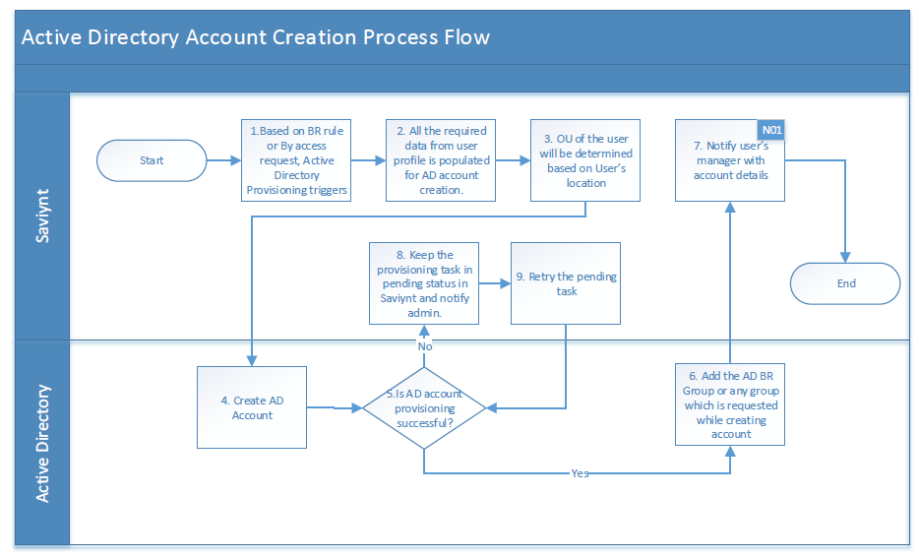
Description:
The following actions take place when a new AD Account is created by Saviynt:
- Pre-populate attributes like First Name, Middle Name and Last Name, Display Name that have a one to one mapping with the fields on the Saviynt profile.
- Saviynt creates a unique id for User Name. Saviynt passes this value to AD as “sAMAccountName”.
- Compute and pre-populate the attribute based on attribute list given in Provisioning Attribute Mapping.
- User dn will be generated based on the user’s location. If the user’s location doesn’t have any assigned OU in AD then dn will be generated with default OU. If request is raised for external user, then account will be created as per the selected Subsidiary.
- Based on the birth right rule or requested by user, the AD groups will be assigned to the user.
- A notification is sent to the user’s manager about the successful creation of the AD account for the user with the following details:
- User Name
- Password
- If the AD account creation is unsuccessful then the failed task report will be sent to Security Tech team with failed task details.

Active Directory Account Modification
The user’s Saviynt profile is updated with attribute changes as a result of updates sent by HCM to Saviynt during an identity reconciliation run. Such changes are then propagated to the AD account of the user to keep it in sync with the recent changes on HCM. The attributes that are monitored for changes are given in Provisioning Attribute Mapping.
The flow of attributes update is depicted in the following workflow:
Figure 26: AD Account Modification
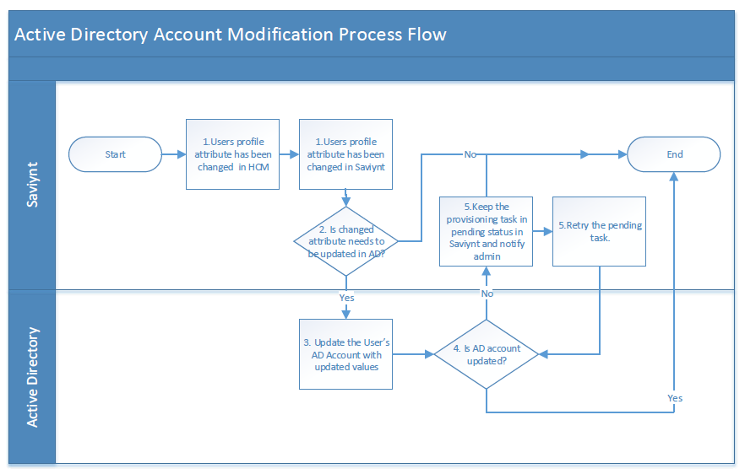
Description:
When Saviynt receives a record from HCM of an identity that already exists in Saviynt,
- Saviynt will detect the attribute on the user’s Saviynt profile that has undergone change and update the same in the user’s Saviynt record.
- As a result of the attribute being updated on the user’s Saviynt record/profile, the user update rule gets triggered which will send the attribute update to the user’s AD account.

Active Directory Account Disable
The user’s Saviynt profile is disabled as a result of termination sent by HCM to Saviynt during an identity reconciliation run. In such event active AD account will be marked as disabled, account will be moved to TBD OU and security groups will be removed from AD account. User can also raise the request for AD account removal.
The flow of account disable is depicted in the following workflow:
Figure 27: AD Account Disable
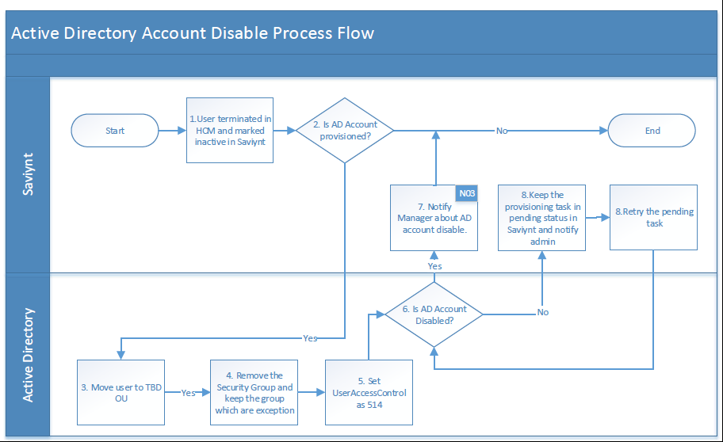
Description:
As a result of a user termination/disable,
- The user’s Saviynt profile will be disabled.
- As a result of the Saviynt profile being disabled, Saviynt disables the user’s AD account.
- AD account of the user will be moved to TBD OU and all the security groups assigned to the user in AD will be removed except below groups if user have these groups provisioned.
  - “NAMEDUSER_NO_RDP”
  - “SERVICEACCOUNTS_NO_RDP”
  - “*zscaler*” (wild card anything match)
  - “*office365*” (wildcard anything match)
  - Domain Users (default group)
  - DomainNoAccess (default group for non-hormel employees)

- AD account expiry date will be set as date of disable.
- The user’s AD account is not deleted as such but rather disabled on the target system and the corresponding account in Saviynt shows up as ‘Disabled’.
- Manager will receive the AD account disable success email for the user.

Active Directory Account Deletion
The user’s Saviynt profile and AD account is disabled for more than 90 days and user don’t have target email address and email attribute set, then AD account of the user will be permanently deleted from AD.
The flow of account deletion is depicted in the following workflow:
Figure 28: AD Account Deletion
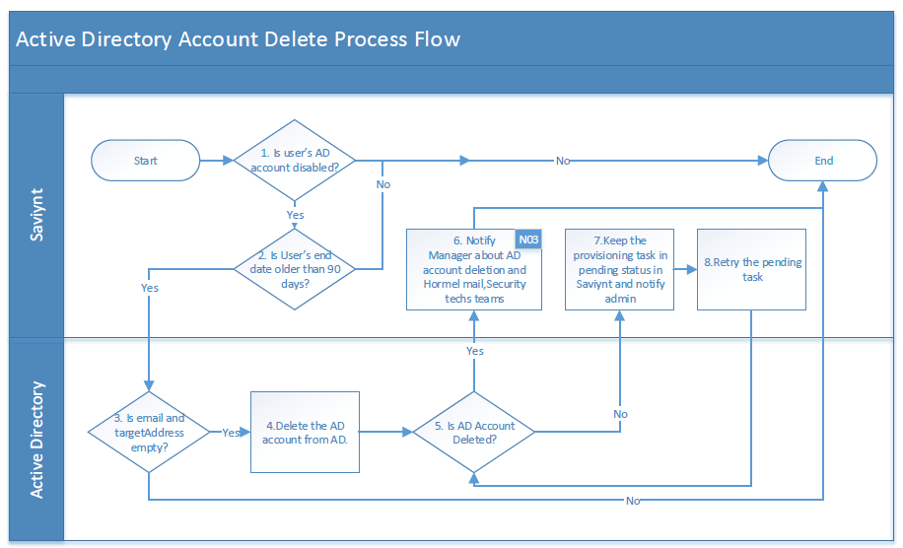
Description:
As a result of a user AD account deletion,
- The user’s Saviynt profile is disabled for more than 90 days.
- The email and target address on AD profile of the user is empty and user’s AD account is present in TBD OU, then AD account will be deleted permanently by Saviynt.
- Manager will receive the AD account termination success email for the user.

Active Directory Account Rehire
When a user is rehired after the termination in HCM then AD account needs to be re-enabled in Saviynt.
The flow of account enable/rehire is depicted in the following workflow:
Figure 29: AD Account Rehire
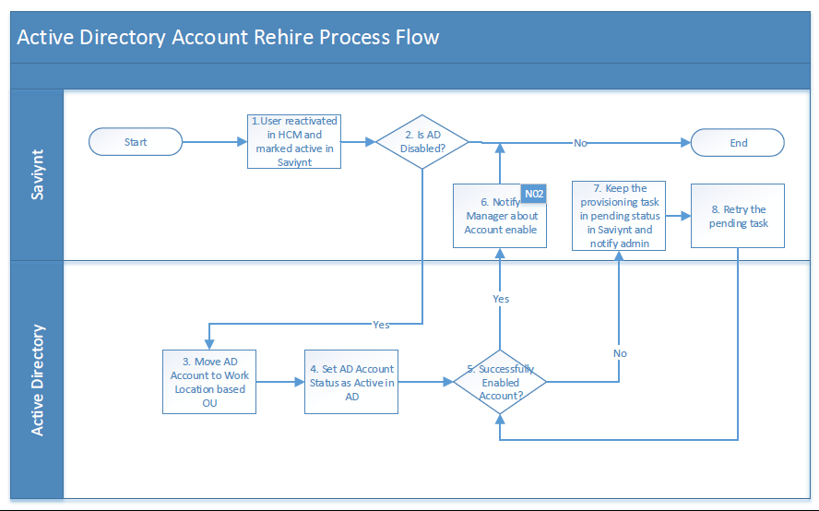
Description:
The following actions take place when a user re-hired after the termination:

- If user has the disabled AD account, then that account gets enabled. If user don’t have AD account, then user gets the new AD account as per Section 4.4.4.
- Any attribute changes that come as part of the rehire record will be propagated to the AD account of the user.
- AD account will be moved to OU based on the user’s location. If user previously belongs to the External OU then user will be moved to the same External OU.
- Manager will receive the AD account enable success email for the user.

Active Directory Add Group
User can raise the request to get the more access in Active Directory. For that they can raise the request in Saviynt.
The flow of group access provisioning is depicted in the following workflow:
Figure 30: AD Add Group
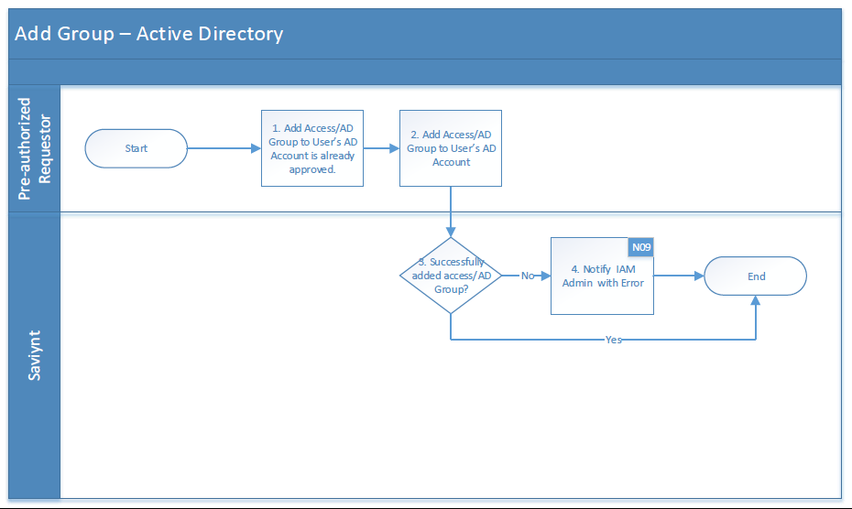
Description:
The following actions take place when group assigned to the user in Active Directory:

- User should have Active Directory account provisioned.
- End user/Manager can raise the request for self or other for Active Directory group. Based on the approval workflow described in section 4.7, the approval will be done for group.
- Once the request is approved the requested group will be provisioned to the user in Active Directory.

Active Directory Remove Group
User can raise the request to remove access from Active Directory. For that they can raise the request in Saviynt.
The flow of group remove access deprovisioning is depicted in the following workflow:
Figure 31: AD Remove Group
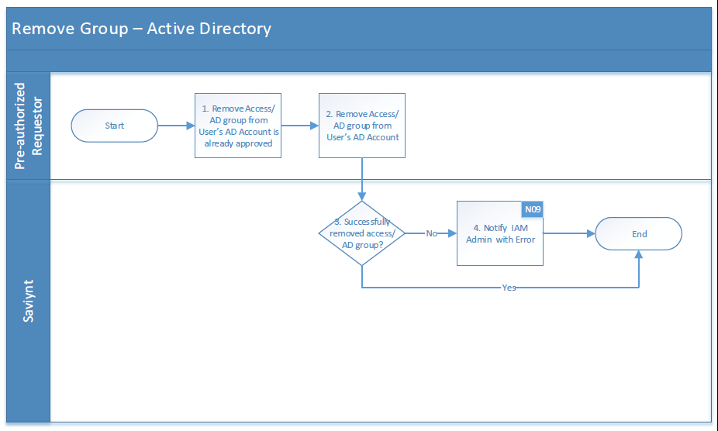
Description:
The following actions take place when a user raise request for group removal:

- User should have Active Directory account provisioned and the group assigned to it.
- End user/Manager can raise the request for self or other for Active Directory group. There is no approval workflow for group removal.
- Once the request is submitted the requested group will be deprovisioned from the Active Directory for the user.

Mailbox Connector Design

User Account Correlation Rule
Users present in Saviynt will be correlated to Mailbox account using below correlation rule.
Table 27 : Active Directory Correlation Rule
Sr No | Saviynt User Attribute Name | Relation | Active Directory Attribute Name
1 | UserName | Equals | sAMAccountName

Provisioning Attribute Mapping
Users mailbox account will be created with the following attributes created on Saviynt while provisioning mailbox account.
Table 28 : Mailbox Provisioning Attribute Mapping
Sr No | Saviynt User Attribute Name | Script Attribute Name | Required for Create JSON? | Any Transformation
1 | UserName | user | Yes
2 | customproperty3 | domain | Yes | Domain will be assigned to the user based on location.

Reconciliation Attribute Mapping
Users account attributes will be updated with the reconciliation attributes that are populated after user account creation on mailbox.
Table 29 : Mailbox Reconciliation Attribute Mapping
Sr No | Saviynt Account Attribute Name | Saviynt Account Attribute Label | Active Directory Attribute Name | Data Type
1 | Name | NAME | SamAccountName | String
2 | created_on | CREATED_ON | WhenMailboxCreated | Date
3 | displayname | DISPLAYNAME | DisplayName | String
4 | accountID | ACCOUNTID | PrimarySmtpAddress | String
5 | accounttype | ACCOUNT TYPE | RecipientType | String
6 | status | STATUS | EmailAddressPolicyEnabled | String
7 | description | DESCRIPTION | Name | String
8 | comments | COMMENTS | DistinguishedName | String
9 | Customproperty 1 | User Principal Name | UserPrincipalName | String
10 | Customproperty 2 | Address List Membership | AddressListMembership | String
11 | Customproperty 3 | Recipient Type Details | RecipientTypeDetails | String
12 | Customproperty 4 | Windows Email Address | WindowsEmailAddress | String
13 | Customproperty 5 | MailTip Translations | MailTipTranslations | String
14 | Customproperty 6 | Alias | Alias | String
15 | Customproperty 7 | Guid | Guid | String
16 | Customproperty 8 | Exchange Guid | ExchangeGuid | String
17 | Customproperty 9 | When Mailbox Created | WhenMailboxCreated | String
18 | Customproperty 10 | Email Addresses | EmailAddresses | String
19 | Customproperty 11 | Email Address Policy Enabled | EmailAddressPolicyEnabled | String

Mailbox Account Creation
When a new hire is created into HCM and the identity reconciliation is run; the new user gets created in Saviynt and a birth right rules gets triggered within Saviynt that provisions the user to Mailbox if the birth right rule is satisfied. Security Techs team can also raise the request for Mailbox account for the users.
The email domain will be provided as per the location of the user. Along with Mailbox account, O365 license groups will be provisioned into AD.
The creation of a Mailbox Account is depicted in the workflow:
Figure 32: Mailbox Account Creation
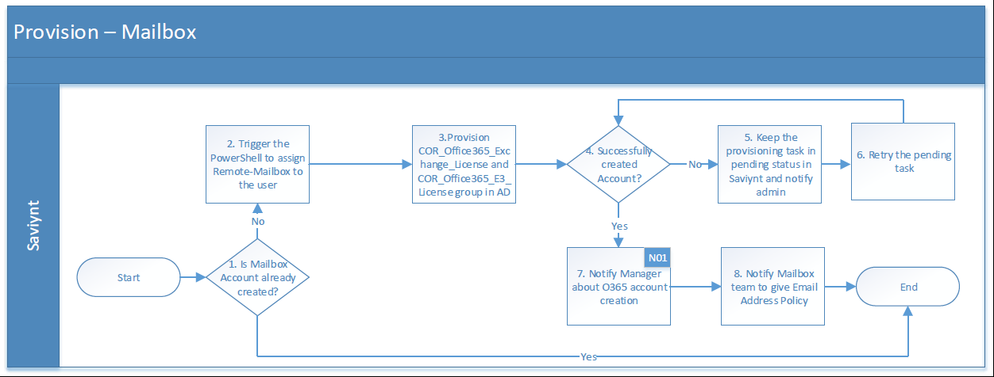
Description:
The following actions take place when a new Mailbox Account is created by Saviynt:
- Provisioning of Mailbox will be triggered only if user already has the Active Directory account provisioned.
- Saviynt creates a unique id for User Name. Saviynt passes this value to Mailbox PowerShell script as “user”.
- Compute and Pre-populate the attribute based on attribute list given in Provisioning Attribute Mapping.
- Email address domain will be created based on the OU user is present in Active Directory.
Example: User is present in OU=JOTS,DC=HFC,DC=AD then the email domain for the Mailbox will be @J-OTS.Com
- COR_Office365_E3_License and COR_Office365_Exchange_License group will be assigned in Active Directory on successful Mailbox creation.
- A notification is sent to the user’s manager about the successful creation of the AD account for the user with the following details:
- User Name
- Email
- A notification will be sent to Mailbox team to assign default Exchange Policy.
- If the Mailbox account creation is unsuccessful then the failed task report will be sent to Mailbox team with failed task details.

Mailbox Account Disable/Deletion
The user’s Saviynt profile is disabled as a result of termination sent by HCM to Saviynt during an identity reconciliation run. In such event active Mailbox account will be marked as disabled, account will be disabled and O365 groups will be removed from AD account. User can also raise the request Mailbox account removal.
The flow of account disable is depicted in the following workflow:

Figure 33: Mailbox Account Disable/Deletion
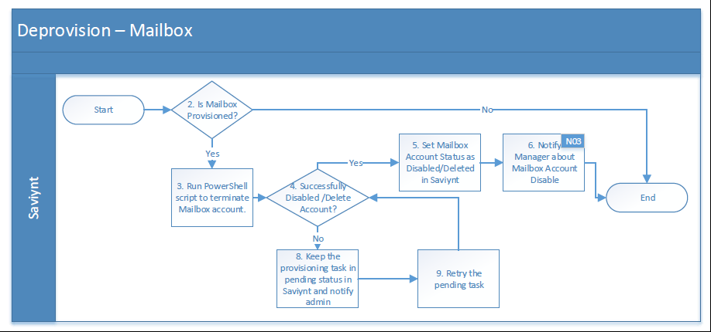
Description:
As a result of a user termination/disable,
- The user’s Saviynt profile will be disabled.
- As a result of the Saviynt profile being disabled Saviynt disables the user’s Mailbox account.
- Saviynt calls the PowerShell script to disable the Mailbox account.
- On successful execution of PowerShell script, Mailbox account status will be marked as Inactive in Saviynt.
- COR_Office365_E3_License and COR_Office365_Exchange_License group will be removed from Active Directory.
- Manager will receive the AD account disable success email for the user.

Oracle HCM identity Update
After accounts are provisioned into Mailbox, Work email is updated back into the HCM system.
Oracle HCM Update application is used to update email back into the HCM system.
SSM solution will use Saviynt certified REST API connector to the provision below fields to Oracle HCM.
Table 30: Oracle HCM Mapping for Data Update
Oracle HCM Attribute | Saviynt Attribute | AD | Required/optional
WorkEmail | customproperty16 | mail | Yes

Approval Workflows
Approvals for new account/access requests are triggered when a user requests the following, Self-Request Access, Modify Existing Access and Request Access for Others.
Account/Access – associated with users and provide users with access to managed applications or systems.
The requester initiates an update account request, provides all the details and submits the request for approval to the next level based on the workflow associated with the application. When the request approval is completed, Saviynt generates the tasks as per requirement.
The approval workflow is one level. At this stage, the approver can perform the following:
- Review the request details and approve individually or together using the approval options.
- Modify the request details and resubmit it for approval with required changes.
- Accept all or reject all based on the suggestive action.
- Monitor different levels of approval details using the task history.

Table 31: Approval Process and Level
Approval Levels
Application | Requester | Manager | Manager’s Manager | Deprovisioning Approval Group
Active Directory, Mailbox Account Provisioning | Self / Non-Manager requesting for others
Active Directory, Mailbox Account Provisioning | Manager for Other User | Auto Approve
Active Directory, Mailbox Account Provisioning | Approver not taken action for 4 days
Active Directory, O365 account Deprovisioning

Birth Right Rules
This section provides details on how birth rights are configured to support specific capabilities for new joiners, including provisioning accounts 14 days prior to the user’s start date.

Birth Right Rules Design
The following section provides details about the Birthright rule to trigger for provision the account and groups/entitlements.
Approach to trigger birthright to support 14 days prior user onboarding is as follow:
- To achieve 14 days prior user onboarding, a custom query is used to calculate days based on the current date and start date (Hire Date) and update the number of days in Saviynt. If the user’s number of days is between 0 to 14 then invoke Update Detective User rule to provision birthright application (AD and Mailbox).

Table 32: Update Detective User Rule
# | Application | Name | Condition
1 | Active Directory/ Mailbox | Provisioning Rules Trigger for User Onboarding | If the number of days is updated in Saviynt then birth right Technical rules will be invoked

- Create the Birthright rule to evaluate the rule and condition to provision the account.

Birth right Rules List
The following list provides list of birth right rules that have been identified while the design was in progress.
Table 33: Birth Right Rule
# | Application |  | Name | Condition | Description
1 | Active Directory | User AD Birth Right Rule for Exempt and Office Hourly Users |  | Users should have the following “People Group”  (O,E)  And  number of days is in between 0 to 14  And  employee type in (‘Employee’,’Pending Worker’)  Then  Provision Account on Active Directory and its Groups  Groups:  NAMEDUSER_NO_RDP, Domain Users | Birth right rule will trigger to automate Active Directory account and groups provisioning to new hires based on employee type and start is less than 14 days prior.
2 | Active Directory | User AD Birth Right Rule for Corp OU Users |  | Users should have the following “Location Description”  (Hormel Corporate Office-North, Hormel Corporate Office-South, Research and Development, Research and Development-Lab)  And  number of days is in between 0 to 14  And  employee type in (‘Employee’,’Pending Worker’)  Then  Provision Account on Active Directory and its Groups  Groups:  NAMEDUSER_NO_RDP, Domain Users | Birth right rule will trigger to automate Active Directory account and groups provisioning to new hires based on employee type and start is less than 14 days prior.
3 | Mailbox | User Mailbox Birth Right Rule for Except and Office Hourly Users |  | User should have Active Directory Account provisioned  Users should have the following “People Group”  (O,E)  And  number of days is in between 0 to 14  And  employee type in (‘Employee’,’Pending Worker’)  Then  Provision Account on Mailbox and assign AD groups  Groups:  COR_Office365_E3_License, COR_Office365_Exchange_License | Birth right rule will trigger to automate Active Directory account and groups provisioning to new hires based on employee type and start is less than 14 days prior.
4 | Mailbox | User Mailbox Birth Right Rule for Corp OU Users |  | User should have Active Directory Account provisioned  Users should have the following “Location Description”  (Hormel Corporate Office-North, Hormel Corporate Office-South, Research and Development, Research and Development-Lab)  And  number of days is in between 0 to 14  And  employee type in (‘Employee’,’Pending Worker’)  Then  Provision Account on Mailbox and assign AD groups  Groups:  COR_Office365_E3_License, COR_Office365_Exchange_License | Birth right rule will trigger to automate Mailbox account and groups provisioning to new hires based on employee type and start is less than 14 days prior.

Business Rules
This section lists and describes the business rules applicable to the proposed system.
Table 34: Business Rule
Business Rule ID | Rule Name | Rule Description
BR001 | UserName Generation Rule | The User Name generation logic will follow the below order for generating User Name until a non-duplicate User Name is generated.  - FirstNameInitialMiddleNameInitialLastNameFull  - FirstNameInitialMiddleNameInitialLastNameFull(1-9)  - FirstNameInitialLastNameFull  - FirstNameInitialLastNameFull(1-9)  If length of user name is greater than 21 than trim the isplayn. If multiple isplayna are there than concatenate all the first names.  If there are multiple Last Names then the concatenate all the last names.
BR002 | Valid Email Domain For User Rule | List of valid email domains for Hormel:  - applegate.com  - columco.com  - fontanini.com  - alselectfoods.com  - dansprize.com  - centuryfoods.com  - burkecorp.com  - mmxfoods.com  - justins.com  - hfcpartners.com  - hormel.com  - j-ots.com  - hfc.ad
BR003 | Email ID Generation Rule | - UserName@domain.com  Domain will be selected based on user’s location.
BR004 | CN Generation Rule | The CN generation logic will follow the below order for generating CN until a non-duplicate CN is generated.  - LastName_FirstName_MiddleInitial  - LastName(1-9)_FirstName_MiddleInitial  - LastName_FirstName  LastName(1-9)_FirstName
BR005 | Active Directory Password Policy | Minimum Numeric Characters: 1  Minimum Special Characters: 1  Disallow Last Password: 24  Blacklisted attributes: User Name, First Name, Last Name  Minimum Length: 12  Maximum Length: 13

Scheduled Tasks
The following section provides details about the scheduled task that will be configured in SSM.
Table 35: Scheduled Task
# | Name | Description | Frequency / Ad-hoc
1 | HCM_USER_IMPORT_RECON | Trusted Reconciliation of users from HCM into Saviynt. (ATOM Feed based Trusted Reconciliation) | Part of HCM_EMPL_DAILY_ONBOARDING job chain
2 | MANAGER_UPDATE_RECON | Full Manager Update Reconciliation based on Manager ID from HCM | Part of HCM_EMPL_DAILY_ONBOARDING job chain
3 | LOCATION_UPDATE_RECON | Incremental Location Update based on Location ID from HCM | Part of HCM_EMPL_DAILY_ONBOARDING job chain
4 | JOBNAME_UPDATE_RECON | Incremental Job Name Update based on Job ID from HCM | Part of HCM_EMPL_DAILY_ONBOARDING job chain
5 | COUNTRY_UPDATE_RECON | Incremental Country Update based on Location ID from HCM | Part of HCM_EMPL_DAILY_ONBOARDING job chain
6 | INITIATE_PROVISIONING_RECON | Reconciliation to set Initiate provisioning flag for newly created users. | Part of HCM_EMPL_DAILY_ONBOARDING job chain
7 | AD_FULL_ACCOUNT_RECON | Full import of accounts from Active Directory. (Full Target Reconciliation) | Every 8 hr
8 | AD_FULL_ENT_RECON | Full import of entitlements Active Directory. (Full Entitlements Load) | Every 8 hr
9 | MAILBOX_FULL_ACCOUNT_RECON | Full import of accounts from Mailbox. (Full Target Reconciliation) | Every 8 hr
10 | HCM_FULL_COUNTRY_RECON | Full import of country accounts from HCM. (Full Target Reconciliation) | Once in Month
11 | HCM_FULL_LOCATION_RECON | Full import of location accounts from HCM. (Full Target Reconciliation) | Every Night
12 | HCM_FULL_JOBNAME_RECON | Full import of jobname accounts from HCM. (Full Target Reconciliation) | Every Night
13 | BIRTHRIGHT_MAILBOX_RECON | Full import of BR flag for Mailbox (UserImportFullJob) | Every 30 min
14 | AD_USER_IMPORT_RECON | Full user import of IT ID from AD(UserImportFullJob) | Part of HCM_EMPL_DAILY_ONBOARDING job chain
15 | EMAIL_HISTORY_JOB | Saviynt job for sending approval notification | Every 5 min
16 | REQUEST_EXPIRY_AFTER_10DAYS | Saviynt job for expiring more than 10 days old request | Every Night
17 | PROVISIONING_TRIGGER_JOB | Saviynt job for pending task processing for all application | Every 15 min
18 | AD_ACCESS_DEPROVISION_RECON | Analytics job for removing AD BR group | Every Night
19 | AD_REMOVE _ACCOUNT_90DAYS_RECON | Analytics job for removing AD account after 90 days of termination | Every Night
20 | HCM_EMPL_DAILY_ONBOARDING | HCM_USER_IMPORT_RECON,MANAGER_UPDATE_RECON,LOCATION_UPDATE_RECON,JOBNAME_UPDATE_RECON,COUNTRY_UPDATE_RECON,INITIATE_PROVISIONING_RECON, AD_USER_IMPORT_RECON | Every 1 Hr
21 | AD_FULL_SYNC | AD_FULL_ACCOUNT_RECON, AD_FULL_ENT_RECON | Every 8 Hr

Physical Design

Physical Architecture Overview

Development Environment
Figure 34: DEV Physical Architecture
Below are the key points about DEV physical architecture for the IDM solution:
- The DEV infrastructure is created in domain hormeltestlab.com.
- The ExpressRoute is setup to facilitate the connection between SSM and enterprise applications.
- The enterprise SaaS applications are connected to SSM over internet.
- The enterprise firewall is configured to allow communication from SSM to enterprise servers/applications via ExpressRoute.

Production Environment
Figure 35: PROD Physical Architecture
Below are the key points for PROD physical architecture for the IDM solution:
- For the enterprise, the PROD infrastructure is created in domain Hormel.com.
- The ExpressRoute is setup to facilitate the connection between SSM and enterprise applications.
- The enterprise SaaS applications are connected to SSM over internet.
- The enterprise firewall is configured to allow communication from SSM to enterprise servers/applications via ExpressRoute.
The enterprise firewalls are configured to allow communication via ExpressRoute to enterprise servers/applications.

Environment Mapping with Connected Systems
Table 36: Environment Mapping with Connected System
SSM | AD | Oracle HCM | Mailbox | Email Server
DEV | Production in a separate OU | TEST | Production | Production. All user’s email is appended with ‘dev’ to eliminate spams.
UAT | Production in a separate OU | TEST | Production | Production. All user’s email is appended with ‘uat’ to eliminate spams.
Prod | Production | Production | Production | Production

SSM Target (Downstream) Environment Details
- Following are the Dev environment details

Table 37: DEV Environment Details
Application | Server | Port
Active Directory (OU) | 172.16.40.82  172.16.42.78 | 636
Oracle HCM | https://ekkh-test.fa.us2.oraclecloud.com | 443
Mailbox (Execute PowerShell Script on Server) | 172.16.165.27 | 443

- Following are the UAT environment details

Table 38: UAT Environment Details
Application | Server | Port
Active Directory (OU) | 172.16.40.82  172.16.42.78 | 636
Oracle HCM | https://ekkh-test.fa.us2.oraclecloud.com | 443
Mailbox (Execute PowerShell Script on Server) | 172.16.165.27 | 443

- Following are the PROD environment details

Table 39: PROD Environment Details
Application | Server | Port
Active Directory | 172.16.40.1 [corsvrdns1.hfc.ad]  172.16.40.2 [corsvrdns2.hfc.ad]  172.16.32.1 [corprddns1.HFC.AD]  172.16.56.1 [corprddns2.hfc.ad] | 636
Oracle HCM | https://ekkh.fa.us2.oraclecloud.com/ | 443
Mailbox (Execute PowerShell Script on Server) | 172.16.41.62 | 443

Hardware Components

Server Pre-requisites
Table 40: Server Pre-Requisites
Server | Description
Windows Server for PowerShell invocation | - Processor: 2.3 GHz 64-bit processor <TBD>  - RAM: 4 GB  - Disk Space: 200 GB  - Windows Server 2012R2  - IIS with .NET 4.5 framework  - Windows PowerShell Framework 5.1  - PowerShell Module for MS Online

Hardware Components

Development Environment
Table 41: DEV Hardware Component
Function | Server Name | IP Address | Type | OS | RAM | Processor
Windows Server for PowerShell | LABTSTSAVAUTO1 | 172.16.165.27 | Virtual | Windows Server 2019 | 6GB | Intel® X®(R) Gold 6140 CPU @ 2.3GHz

UAT Environment
Table 42: UAT Hardware Component
Function | Server Name | IP Address | Type | OS | RAM | Processor
Windows Server for PowerShell | LABTSTSAVAUTO1 | 172.16.165.27 | Virtual | Windows Server 2019 | 6GB®te®) Xeon(R) Gold 6140 CPU @ 2.3GHz

Production Environment
Table 43: PROD Hardware Component
Function | Server Name | IP Address | Type | OS | RAM | Processor
Windows Server for PowerShell | COBPRDSAVAUTO1 | 172.16.41.62 | Virtual | Windows Server 2016 | 6GB | I®l(R) Xeon(R) Gold 6140 CPU @ 2.3GHz

High Availability
High Availability pertains to capabilities that aim to reduce the downtime of a system due to faults.
Table 44: High Availability
Saviynt Cloud | Saviynt offers a reliable, fault-tolerant and highly available system to meet enterprise needs. Saviynt supports load balancing and clustering at various levels to provide HA solution and uses real-time replication to support failover mode.  High Availability of all cloud-hosted components is natively supported by Saviynt. It is assumed that availability SLAs are defined as part of Hormel’s subscription contracts.

Operations Design

Security
The Saviynt Security Manager (SSM) is a SaaS application and Saviynt is responsible for the Physical and Logical Security of its platform components that are hosted on the cloud.

Authentication
Table 45: Authentication
Component | Authentication Mechanism
Saviynt Cloud Web Interface | Saviynt Cloud is SSO enabled at Hormel and users will login to Saviynt using their Azure credentials. The Web Interface is accessible from anywhere – within or outside Hormel network perimeter.

Saviynt Operational Roles
The following list provides detailed entitlements of various Saviynt Roles that will be created. These roles provide appropriate capabilities to users within Saviynt.
Table 46: Saviynt Operational Roles
Saviynt Role Name | Linked Persona | Privileged Role? | Sub-Menu Entitlement Values
ROLE_HORMEL_ENDUSER | End-User | No | - SUBMENU.ARS.workflowmanagement_requesthome  - SUBMENU.ARS.jbpmworkflowmanagement_showmyhistoryrequests  - SUBMENU.ARS.jbpmworkflowmanagement_viewopenrequests  - SUBMENU.ARS.workflowmanagement_requesthomedashboard  - SUBMENU.ARS.workflowmanagement_remaccess  - SUBMENU.ARS.jbpmworkflowmanagement_remaccess  - SUBMENU.ARS.arsDashboard_remaccess
ROLE_ ADMIN | IAM Administrator | Yes | All available sub menu items except for below four:  - SUBMENU.ATTESTATION.attestations_list  - SUBMENU.ATTESTATION.attestations_remaccess  - SUBMENU.WEBSERVICE.webservice_generateToken  - SUBMENU.WEBSERVICE.webservice_refreshToken
ROLE_HORMEL_HELPDESK | Hormel Helpdesk | Yes | - Below is attached sheet with all access required for Helpdesk SAV roles.
ROLE_HORMEL_ADMIN | Security Techs Team | Yes | - SUBMENU.ARS.workflowmanagement_requesthome  - SUBMENU.ARS.jbpmworkflowmanagement_showmyhistoryrequests  - SUBMENU.ARS.jbpmworkflowmanagement_viewopenrequests  - SUBMENU.ARS.workflowmanagement_requesthomedashboard  - SUBMENU.ARS.workflowmanagement_remaccess  - SUBMENU.ARS.jbpmworkflowmanagement_remaccess  - SUBMENU.ARS.arsDashboard_remaccess  - SUBMENU.ARS.firefighter  - SUBMENU.ARS.workflowmanagement_multiuseruploadpreview  - SUBMENU.ARS.create_userrequest  - SUBMENU.ARS.workflowmanagement_requesthomepam  - SUBMENU.ARS.pmgmt_checkpasswordstrength  - SUBMENU.ARS.pmgmt_checkpasswordstrengthuserpolicy

Role Governance
SSM supports the versioning of enterprise roles. Any updates/modifications to an existing enterprise role will trigger role approvals. IAM administrators will act as role owners, and any modifications to a role will be approved by them. When a role is modified, it will be in the composition state, and it will not be available in access request until it is approved by the IAM administrators.

Deployment Methodology
The current Saviynt product version, v5.5.0 SP3, does have export/import functionality for product configurations. The recommended approach from the Saviynt is to move the product configuration from one environment to another using transport functionality in Saviynt. KPMG Development team will work with the Saviynt team to move the implemented product configuration from DEV to PROD.

Backup and Recovery
Disaster recovery (DR) is an area of security planning that aims to protect an organization from the effects of significant negative events. Having a disaster recovery strategy in place enables an organization to maintain or quickly resume mission-critical functions following a disruption.

DR Terminology
- Recovery Time Objective (RTO): Once an outage/disruption occurs, this is the acceptable time frame within which an asset or business process needs to be recovered/restored in accordance to the set SLA levels.
- Recovery Point Objective (RPO): This refers to the point in time in the past to which the system will need to recover once an outage/disruption has occurred.
- The RPO is the point to which we will have all data up to that point recovered. The gap between the disaster and the RPO will likely be lost as a result of the disaster.
- On the timeline, RTO is the point at which the system will be back up and running. The gap between the disaster and the RTO is the timeframe for which the app will be down and non-functioning.

High-Level Backup and Archival Strategy
Table 47 : DR Terminology
Data | Storage | Technology | Typical Retention Period
Logs Backup | Application Server logs and Tomcat logs | Azure | Saviynt policy is to maintain logs for active viewing in Azure instance.  Application Logs will be maintained on Azure instance or a centralized logging server as per requirement.  - Logs up-to last 1 week will be persisted on Azure instance or (Centralized Logging Server).  - Logs which are older than 1 week will be purged.
Data Backup | Snapshot of RDS instance volumes | Azure | As per our backup policy, Saviynt stores snapshot of RDS instances.  The frequency of snapshots is 1 back-up per day at 10:00 AM UTC.  The retention policy for RDS as below:  - Retention Period for Prod: 30 days  - Retention Period for Non-Prod: 7 days

Patch and Upgrades
Table 48: Patch and Upgrade
Saviynt Cloud | All patching and upgrades will be handled automatically by the Saviynt team.

Health check monitoring
Table 49: Health Check Monitoring
Saviynt Cloud | Health check monitoring for Saviynt cloud is natively managed by Saviynt and Azure. SaaS typically obligated to inform organizations in case of environment availability issues that are outside the contractually obligated SLAs.

Logging
Saviynt provides a web interface to review and download server-level logs. Hormel’ IAM Administrators will have access for troubleshooting purpose.
Note: While the design document is being prepared, the above details are yet to be provided by Hormel. Once the details are provided, this section will be updated.

Certificates
- All certificates linked to SSM components will be managed by SSM.
- Certificates linked to SaaS solutions like Oracle HCM integration will be managed by SSM.
- Certificates linked to Active Directory integration will need to be managed by the Hormel and Saviynt team.

NTP Setup
For consistent timekeeping in the IDM solution, NTP will be leveraged to keep the servers in a synchronized time zone. The enterprise IDM solution will have two different NTP servers.
- Saviynt cloud NTP

Saviynt Cloud NTP
As depicted in Section 5.1, the Saviynt Security Manager will be deployed in the cloud environment. The cloud service provider will have another NTP server to keep the cloud instances in synchronized time zones. Saviynt provides OOTB NTP synchronization across cloud SSM instances which will also be leveraged for IDM solution.

Reports
SSM offers OOTB analytics capabilities that include SQL based reporting functionality. In the enterprise, it is vital to have system insight based on extensive reports for identity profiles and application accounts. Saviynt also offers actionable reports which include taking different actions like enable, accept, revoke, further review, etc. on the reports.
Table 50: Saviynt Analytics Report
Analytics Name | Description
Hormel Active Directory Failure Task | Provides the failure task details for Active Directory application
Hormel Mailbox Failure Task | Provides the failure task details for Mailbox application
Hormel Open Provisioning Tasks | View Open provisioning tasks
Hormel Reconciliation Failure | Provides reconciliation failure job details.
Hormel Users Deleted in the Next 24 hours | Remove AD Account in next 24 hrs.
Hormel Users with Improper Hormel Email Address | View users with empty or improper email addresses

Requirements Traceability Matrix
Table 51: Requirement Traceability Matrix
# | Process | Front End – UX | Back end  Components
1.1 | Joiner – Employee | Not Applicable | Section 4.3 – Identity Use Case Design  Section 4.8 Birthright Rules  Section 9.2 - Notifications
1.2 | Rehire – Employee | Not Applicable | Section 4.3 – Identity Use Case Design  Section 4.8 Birthright Rules  Section 9.2 - Notifications
1.3 | Profile Change – Employee | Not Applicable | Section 4.3 – Identity Use Case Design  Section 4.4.5 – Active Directory Account Modification
1.4 | Leaver - Employee | Not Applicable | Section 4.3 – Identity Use Case Design  Section 4.4.6 – Active Directory Account Disable  Section 4.4.7 – Active Directory Account Deletion  Section 4.5.5 – Mailbox Account Disable  Section 4.5.5 – Mailbox Account Deletion
2.1 | Approval Process | Section 4.7
2.2 | Provisioning – Active Directory |  | Section 4.4.4
2.3 | Provisioning – Mailbox |  | Section 4.5.4
2.4 | Provisioning – Active Directory Group |  | Section 4.4.9
2.5 | Deprovisioning – Active Directory Group |  | Section 4.4.10
2.6 | Deprovisioning – Active Directory |  | Section 4.4.7
2.7 | –eprovisioning - Mailbox |  | Section 4.5.5
2.8 | Enable – Active Directory |  | Section 4.4.8

Design Challenges and Decisions
Table 52: Design Challenges and Decision
Sr No | Problem Statement | Decision
1 | Birth Right rule logic for Active Directory and Mailbox | There is no documented logic on what are all the base access that a user gets as part of user creation.  Based on discussion with Hormel team below is the criteria we have finalized to give Active Directory and Mailbox as birth right.  Rule 1: Employee Type is Employee or Pending Worker and People Group is E or O  Rule 2: Employee Type is Employee or Pending Worker and Location Description is in Hormel Corporate Office-North, Hormel Corporate Office-South, Research and Development, Research and Development-Lab  If user’s data falls under any of the above criteria, then user will get the Active Directory and Mailbox as birth right.
2 | Strategy to look for entitlement owners that are terminated | Hormel has a concern today that the entitlements whose owners are terminated will remain with them only to find out at a later stage when request is standing in pending state for long. So, they wanted Saviynt to take care of it automatically.  Approach: For every user Owner on Terminate attribute needs to be setup with the username who can take the ownership of entitlement once the user is disabled. This attribute needs to be populated on user profile before the user is disabled. Then once user is disabled, it’s ownership will be transferred to the user who is set as Owner on Terminate of the disabled user.
3 | Decision on Unique Identifier or username for Saviynt | The username for Saviynt is a decision to be made as not all users gets AD account ’reated. So, we'll be going ahead with the sAMAccountName logic to create a username and irrespective of the type of users, every user must be created on HCM from now on and must be reconciled to Saviyn’ from where it'll be translated to all the downstream systems.
4 | Target Application usernames that cannot follow sAMAccountName | It is decided that the sAMAccountName will be the username going forward, all the target systems that are integrated with Saviynt will be getting full sAMAccountName as usernames where needed however there are certain applicat’ons that doesn't allow more than certain number of characters in their username unlike username that has no such restriction. All such application username expectations will be handled manually outside Saviynt.  Saviynt will generate the username of maximum length 21 character.
5 | Source of truth changes to HCM for all user types going forward | As of today, even though employees are created on HCM first and then created on target system, contingent workers/brokers are created on target systems first and then are created on HCM. Going forward this needs to change as Saviynt should be source of username generation.
6 | IT ID update in Saviynt | All the users within Hormel are given an IT ID or unique ID generated by CAS system in order to tie their access across all target systems. We want to integrate saviynt with PWEB database so we can get that IT ID within Saviynt.  Decision: Saviynt will reconcile the IT ID from Active Directory instead of PWEB database.
7 | Day 0 load of users from AD | There are many OUs that are in AD and as we will be loading users into SSM from AD first, we need a logic through which we can pull in those users. This will help us remove any service accounts or non-named accounts.  Approach: Get the export from AD team using below filter as this filter will return only Hormel users.  Get-ADUser -Filterisplaynameies displayName,sAMAccountName,employeeNumber,userAccountControl| Where-Object {`  ($_.Distingui“hedName -li”e "*OU=Users,*") -and `  ($_.Distinguishe“Name -notlike "*”U=Restricted,*") -and `  ($_.Distinguishe“Name -notlike "*OU=Depar”mental Units,*") -and `  ($_.Distinguishe“Name -notli”e "*OU=Farms,*") -and `  ($_.Distinguishe“Name -notlike "*OU=GenericUse”sMailEnabled,*") -and `  ($_.Distinguishe“Name -not”ike "*OU=NVR,*") -and `  ($_.Distinguishe“Name -notlike "*OU=PCAu”oLockTesting,*") -and `  ($_.Distinguishe“Name -notlike "*OU=P”ant accounts,*") -and `  ($_.Distinguishe“Name -notlike”"*OU=Vendors,*") } | Export-csv C:\User.csv
8 | Birth right groups for AD account | There is no exact list of security groups needs to be assigned to the user as birth right.  Decision: On AD birth right provisioning Saviynt will provision the below 2 security group to the user.  NAMEDUSER_NO_RDP, Domain Users
9 | Decision for delegation of mailbox | Currently on user termination user’s mailbox is assigned to the user and the user to whom the mailbox needs to be delegated is decided at runtime.  In Saviynt there is no way to send the delegated user’s detail runtime. The delegate user should be already present on user profile in one attribute then only it will be passed to PowerShell script.  Decision: The delegation block from existing PowerShell script will be executed manually after Saviynt completes the disable task in saviynt.
10 | Exchange online policy assignment | As of today, the exchange online policy will be given to the user 30 minutes after the mailbox creation. This is not possible to be provisioned from Saviynt.  Decision: On the Mailbox account creation Saviynt will send the email to Mailbox team to assign the Exchange online policy.
11 | Disable Mailbox hold for legal purpose | Sometime disabled Mailbox are not deleted for some legal purpose but Saviynt will not have any way to identify this. So, if user is disabled for more than 90 days then the users AD account will be deleted, and mailbox will still be with legal hold team.
12 | Change Password on N–xt Logon flag - Active Directory
13 | HCM User Day 0 Load | To pull the all user from HCM, Saviynt calls the HCM REST API and to pull all the users from HCM the api takes lots of time. So, using REST API to pull the day 0 user from HCM is not feasible option consider the amount of time it takes.  Decision: HCM team will give the CSV file in required format for all active Employee and Contingent Worker. This CSV file then will be loaded in Saviynt manually on production before go live. This will be the one-time activity in production.
14 | StreetAddress | Saviynt has limitation that it cannot parse and send a new line character to Active Directory while provisioning. The same was informed to Hormel team and was agreed that the streetAddress will be populated with a comma separator than a new line.
15 | ExtensionAttribute1 | GL attributes are not available for Saviynt to fetch from HCM through API. Hence these were taken out of scope and will be updated outside Saviynt operations.
16 | Name change flow to AD | On users first name/last name/middle name change, users SamAccountName/UPN/cn/dn/display name should be changed to AD but Saviynt has limitation to regenerate the username and system user name on name change in Saviynt.  Decision: Hormel team will change the user’s username and display in saviynt on such name change request and that will flow to active directory from saviynt. Saviynt will send the report of name mismatch report to Security Tech team
17 | Approval on Remove Access | User can raise the request for account removal and there is no approval required for removal from manager or any other person. Now saviynt will have the approval workflow for removal and that approval will go to one group where Hormel team as assigned as approver the request.

Appendix

Key Terminologies
Table 53: Key Terminologies
Terminology | Definition
Employee | Full / Part-time Employees who are managed via the Hormel’s HR system.
Other Users | Contractor / Consultants /Brokers who are managed in Hormel’s HR system and Active Directory currently.
Identity | Identity is a system of record that is uniquely associated with a user within an organization. Each user, Full time, part-time, contractor or consultant within Hormel should have one and only one identity. In mature IAM programs, an identity is uniquely defined using a Global Unique Id (GUID), which would stay with the user for life.
Account | An account is a system of record that is associated with various technologies users gain access to, for example, Active Directory, Salesforce, etc. An IAM system would link identities to accounts across various integrated technologies. An identity may have none, one or more accounts based on the environment. If an account can’t be associated with an identity, it is considered an orphan account. Having such accounts adds the risk of unauthorized access to an organization.
Up-stream System | An Up-stream system refers to the authoritative source of user records within an organization. At Hormel, Oracle HCM is considered the up-stream system for Employees and Contingent Worker.
Down-stream system | A downstream system refers to integration applications or technologies in which accounts are managed by IAM technologies. For the scope of this engagement, downstream systems collectively refer to Salesforce, Active Directory, Microsoft Exchange Mailbox, and Oracle EBS.
Entitlement Owner | Set of users who are approver for the Active Directory groups assignment.
Trusted Reconciliation | Reconciliation of Identities from a trusted source( Oracle HCM). All the user identity record is reconciled into SSM by using the HCM_IMPORT_JOB.
Target Reconciliation | All the Account and Access are reconciled from the Down-stream application into SSM by using Scheduling Job.

Notifications
In the enterprise, the IDM solution will be responsible for sending notification emails to the appropriate users/teams as required. SSM’s OOTB email templates will be leveraged to create the email notifications. The Enterprise SMTP server will be used to facilitate the email delivery to the users, managers, and other relevant teams.
The IDM notification will not be configurable as actionable. These emails will be ‘DO NOT REPLY’ type system notifications. This section describes the notifications template that is the reference in the Process Document.

N01# Active Directory User Account Creation
Table 54: Active Directory User Account Creation
Active Directory User Account Creation
Type | Text
From | noreply@hormel.com
To | Users Manager
Cc/Bcc
Subject | Active Directory User Account Provisioned - ${user?.firstname} ${user?.lastname}
Message | Dear ${manager?.firstname} ${manager?.lastname},  You are receiving this email from the Access Central Administrator to alert you that a new account has been created in ${task?.endpoint?.displayName} for ${user?.firstname} ${user?.lastname} [${task?.accountName}].  Login Information  User ID: ${user?.username}  Password:${task?.password}  Please communicate these credentials to the new user. If the new user has an assigned Hormel workstation, they should log in and they will be prompted to reset their password upon first login.  If you have any questions please log onto Service Central and create a ticket. Do not reply to this email as the mailbox is not monitored.  Thank You,  Access Central Administrator

N02# Active Directory User Account Disable
Table 55: Active Directory User Account Disable
Active Directory User Account Disable
Type | Text
From | noreply@hormel.com
To | Users Manager
Cc/Bcc
Subject | Active Directory User Account Disable- ${user?.firstname} ${user?.lastname}
Message | Dear ${manager?.firstname} ${manager?.lastname},  You are receiving this email from the Access Central Administrator to alert you that an account has been disabled in ${task?.endpoint?.displayName} for ${user?.firstname} ${user?.lastname}  Login Information  User ID: ${user?.username}  If you have any questions please log onto Service Central and create a ticket. Do not reply to this email as the mailbox is not monitored.  Thank You,  Access Central Administrator

N03# Active Directory User Account Enable
Table 56: Active Directory User Account Enable
Active Directory User Account Enable
Type | Text
From | noreply@hormel.com
To | Users Manager
Cc/Bcc
Subject | Active Directory User Account Enable - ${user?.firstname} ${user?.lastname}
Message | Dear ${manager?.firstname} ${manager?.lastname},  You are receiving this email from the Access Central Administrator to alert you that an account has been enabled in ${task?.endpoint?.displayName} for ${user?.firstname} ${user?.lastname}  Login Information  User ID: ${user?.username}  If you have any questions please log onto Service Central and create a ticket. Do not reply to this email as the mailbox is not monitored.  Thank You,  Access Central Administrator

N04# Active Directory User Account Deleted
Table 57: Active Directory User Account Deleted
Active Directory User Account Deleted
Type | Text
From | noreply@hormel.com
To | Users Manager
Cc/Bcc
Subject | Active Directory User Account Deleted - ${user?.firstname} ${user?.lastname}
Message | Dear ${manager?.firstname} ${manager?.lastname},  You are receiving this email from the Access Central Administrator to alert you that an account has been deleted in ${task?.endpoint?.displayName} for ${user?.firstname} ${user?.lastname}  Login Information  User ID: ${user?.username}  If you have any questions please log onto Service Central and create a ticket. Do not reply to this email as the mailbox is not monitored.  Thank You,  Access Central Administrator

N05# Active Directory User Account Creation For Security Techs Team
Table 58: Active Directory User Account Creation For Security Techs Team
Active Directory User Account Creation For Security Techs Team
Type | Text
From | noreply@hormel.com
To | Security Techs Team
Cc/Bcc
Subject | Active Directory User Account Provisioned - ${user?.firstname} ${user?.lastname}
Message | Dear Security Techs Team,  You are receiving this email from the Access Central Administrator to alert you that a new account has been created in ${task?.endpoint?.displayName} for ${user?.firstname} ${user?.lastname} [${task?.accountName}].  Login Information  User ID: ${user?.username}  Password:${task?.password}  Please create the Home Directory for the user if required in Active Directory.  If you have any questions please log onto Service Central and create a ticket. Do not reply to this email as the mailbox is not monitored.  Thank You,  Access Central Administrator

N06# Mailbox User Account Creation
Table 59: Mailbox User Account Creation
Mailbox User Account Creation
Type | Text
From | noreply@hormel.com
To | User Manager
Cc/Bcc
Subject | Mailbox User Account Provisioned - ${user.firstname} ${user.lastname}
Message | Dear ${manager?.firstname} ${manager?.lastname},  You are receiving this email from the Access Central Administrator to alert you that a new account has been created in ${task?.endpoint?.displayName} for ${user?.firstname} ${user?.lastname} [${task?.accountName}].  Login Information  User ID: ${user?.username}  Email: ${user?.email}  Please communicate these email details to the user. As a part of the email setup process ${user?.firstname} ${user?.lastname} will need to set up Multi-Factor Authentication. The instructions can be found by searching Service Central Knowledge Base for the appropriate article below. Refer to the article which matches the type of phone which will be used when entering an authorization code.  If you have any questions please log onto Service Central and create a ticket. Do not reply to this email as the mailbox is not monitored.  Thank You,  Access Central Administrator
  Type | Article | Title | Collection
  Document | 10868 | New Hormel User Azure MFA and SSPR Registration Instructions for iPhone | Customer Knowledge
  Document | 10866 | New Hormel Partner Azure MFA and SSPR Registration and VPN Instructions | Customer Knowledge
  Document | 10867 | New Hormel User Azure MFA and SSPR Registration Instructions for Android | Customer Knowledge

N07# Mailbox User Account Creation For Mailbox Team
Table 60: Mailbox User Account Creation For Mailbox Team
Mailbox User Account Creation For Mailbox Team
Type | Text
From | noreply@hormel.com
To | Mail Sec Admin Team
Cc/Bcc
Subject | Mailbox User Account Provisioned - ${user.firstname} ${user.lastname}
Message | Dear Mail Sec Admin Team,  You are receiving this email from the Access Central Administrator to alert you that a new account has been created in ${task?.endpoint?.displayName} for ${user?.firstname} ${user?.lastname} [${task?.accountName}].  Login Information  User ID: ${user?.username}  Email: ${user?.email}  Please update the Email Address Policy for the user.  If you have any questions please log onto Service Central and create a ticket. Do not reply to this email as the mailbox is not monitored.  Thank You,  Access Central Administrator

N08# Mailbox User Account Disabled
Table 61: Mailbox User Account Disabled
Mailbox User Account Disabled
Type | Text
From | noreply@hormel.com
To | User Manager
Cc/Bcc
Subject | User Mailbox Disabled - ${user?.firstname} ${user?.lastname}
Message | Dear ${manager?.firstname} ${manager?.lastname},  You are receiving this email from the Access Central Administrator to alert you that an account has been deleted in ${task?.endpoint?.displayName} for ${user?.firstname} ${user?.lastname}  Login Information  User ID: ${user?.username}  Email ID: ${user?.email}  If you have any questions please log onto Service Central and create a ticket. Do not reply to this email as the mailbox is not monitored.  Thank You,  Access Central Administrator

N09# Access Request Assignment Email Notification
Table 62: Access Request Assignment Email Notification
Access Request Assignment Email Notification
Type | Text
From | noreply@hormel.com
To | ${assignee.email}
Cc/Bcc
Subject | Please review access request ID: ${requestid} for ${user.firstname} ${user.lastname} [${user.username}].
Message | Dear ${assignee?.firstname} ${assignee?.lastname},  You are receiving this email from the Access Central Administrator to alert you that Access request ID: ${requestid} has been submitted for ${user.firstname} ${user.lastname} [${user.username}]. This request has been submitted by ${requestor.firstname} ${requestor.lastname} [${requestor.username}].  The request is for the following application and access:  Application Name: ${endpoint}  Entitlements:${entitlement_values?.displayname}  Please login to Access Central application to view details and complete this request. If no action is taken by ${(request.requestdate + 4).format("MMMM dd, yyyy")}, the request will be assigned to your manager. The request will be expired on ${(request.requestdate + 10).format("MMMM dd, yyyy")}.  If you have any questions please log onto Service Central and create a ticket. Do not reply to this email as the mailbox is not monitored.  Thank You,  Access Central Administrator

N10# Access Request Reminder Email Notification
Table 63: Access Request Reminder Email Notification
Access Request Reminder Email Notification
Type | Text
From | noreply@hormel.com
To | ${assignee.email}
Cc/Bcc
Subject | Access request reminder for request ID: ${requestid} for ${user.firstname} ${user.lastname}.
Message | Dear ${assignee?.firstname} ${assignee?.lastname},  You are receiving this email from the Access Central Administrator to alert you that Access request ID: ${requestid} has not been completed by you for ${user.firstname} ${user.lastname} [${user.username}].If no action is taken by ${(request.requestdate + 4).format("MMMM dd, yyyy")}, the request will be assigned to your manager. The request will be expired on ${(request.requestdate + 10).format("MMMM dd, yyyy")}.  The request is for the following application and access:  Application Name: ${endpoint}  Entitlements:${entitlement_values?.displayname}  Please login to Access Central application to view details and complete this request.  If you have any questions please log onto Service Central and create a ticket. Do not reply to this email as the mailbox is not monitored.  Thank You,  Access Central Administrator

N11# Access Request Reassignment Email Notification
Table 64: Access Request Reassignment Email Notification
Access Request Reassignment Email Notification
Type | Text
From | noreply@hormel.com
To | ${assignee.email}
Cc/Bcc
Subject | Please review access request ID: ${requestid} for ${user.firstname} ${user.lastname} [${user.username}].
Message | Dear ${assignee?.firstname} ${assignee?.lastname},  You are receiving this email from the Access Central Administrator to alert you that Access request ID: ${requestid} has not been completed by previous approver and has been escalated to you for further action. This request has been submitted by ${requestor.firstname} ${requestor.lastname} [${requestor.username}] for ${user.firstname} ${user.lastname} [${user.username}].  The request is for the following application and access:  Application Name: ${endpoint}  Entitlements: ${entitlement_values?.displayname}  Please login to Access Central application to view details and complete this request. If no action is taken by ${(request.requestdate + 10).format("MMMM dd, yyyy")}, the request will be cancelled.  If you have any questions please log onto Service Central and create a ticket. Do not reply to this email as the mailbox is not monitored.  Thank You,  Access Central Administrator

N12# Access Request Approved Email Notification
Table 65: Access Request Approved Email Notification
Access Request Approved Email Notification
Type | Text
From | noreply@hormel.com
To | ${requestor.email}
Cc/Bcc
Subject | Access request approved request ID: ${requestid} for ${user.firstname} ${user.lastname} [${user.username}].
Message | Dear ${requestor?.firstname} ${requestor?.lastname},  You are receiving this email from the Access Central Administrator team to alert you that Access request ID: ${requestid} has been approved for ${user.firstname} ${user.lastname} [${user.username}].  The request is for the following application and access:  Application Name: ${endpoint}  Entitlements: ${entitlement_values?.displayname}  Please login to Access Central application to view more details of this request.  If you have any questions please log onto Service Central and create a ticket. Do not reply to this email as the mailbox is not monitored.  Thank You,  Access Central Administrator

N13# Access Request Rejected Email Notification
Table 66: Access Request Rejected Email Notification
Access Request Rejected Email Notification
Type | Text
From | noreply@hormel.com
To | ${requestor.email}
Cc/Bcc
Subject | Access request rejected with request ID: ${requestid} for ${user.firstname} ${user.lastname} [${user.username}].
Message | Dear ${requestor?.firstname} ${requestor?.lastname},  You are receiving this email from the Access Central Administrator to alert you that Access request ID: ${requestid} has been rejected for ${user.firstname} ${user.lastname} [${user.username}].  The request is for the following application and access:  Application Name: ${endpoint}  Entitlements:${entitlement_values?.displayname}  Please login to Access Central application to view more details of this request.  If you have any questions please log onto Service Central and create a ticket. Do not reply to this email as the mailbox is not monitored.  Thank You,  Access Central Administrator

N14# Access Request Expired Email Notification
Table 67: Access Request Expired Email Notification
Access Request Expired Email Notification
Type | Text
From | noreply@hormel.com
To | ${requestor.email}
Cc/Bcc
Subject | Access request expired request ID: {requestid} for {user.firstname} {user.lastname} [{user.username}].
Message | Dear ${requestor?.firstname} ${requestor?.lastname},  You are receiving this email from the Access Central Administrator to alert you that Access request ID: ${requestid} has been expired.  Please login to Access Central application to view more details of this request.  If you have any questions please log onto Service Central and create a ticket. Do not reply to this email as the mailbox is not monitored.  Thank You,  Access Central Administrator

N15# Account Request Assignment Email Notification
Table 68: Account Request Assignment Email Notification
Account Request Assignment Email Notification
Type | Text
From | noreply@hormel.com
To | ${assignee.email}
Cc/Bcc
Subject | Please review access request ID: ${requestid} for ${user.firstname} ${user.lastname} [${user.username}].
Message | Dear ${assignee?.firstname} ${assignee?.lastname},  You are receiving this email from the Access Central Administrator to alert you that Access request ID: ${requestid} has been submitted for ${user.firstname} ${user.lastname} [${user.username}]. This request has been submitted by ${requestor.firstname} ${requestor.lastname} [${requestor.username}].  The request is for the following application :  Application Name: ${endpoint}  Please login to Access Central application to view details and complete this request. If no action is taken by ${(request.requestdate + 4).format("MMMM dd, yyyy")}, the request will be assigned to your manager. The request will be expired on ${(request.requestdate + 10).format("MMMM dd, yyyy")}.  If you have any questions please log onto Service Central and create a ticket. Do not reply to this email as the mailbox is not monitored.  Thank You,  Access Central Administrator

N16# Account Request Reminder Email Notification
Table 69: Account Request Reminder Email Notification
Account Request Reminder Email Notification
Type | Text
From | noreply@hormel.com
To | ${assignee.email}
Cc/Bcc
Subject | Account request reminder for request ID: ${requestid} for ${user.firstname} ${user.lastname}.
Message | Dear ${assignee?.firstname} ${assignee?.lastname},  You are receiving this email from the Access Central Administrator to alert you that Access request ID: ${requestid} has not been completed by you for ${user.firstname} ${user.lastname} [${user.username}].If no action is taken by ${(request.requestdate + 4).format("MMMM dd, yyyy")}, the request will be assigned to your manager. The request will be expired on ${(request.requestdate + 10).format("MMMM dd, yyyy")}.  The request is for the following application:  Application Name: ${endpoint}  Please login to [Access Central] application to view details and complete this request.  If you have any questions please log onto Service Central and create a ticket. Do not reply to this email as the mailbox is not monitored.  Thank You,  Access Central Administrator

N17# Account Request Reassignment Email Notification
Table 70: Account Request Reassignment Email Notification
Account Request Reassignment Email Notification
Type | Text
From | noreply@hormel.com
To | ${assignee.email}
Cc/Bcc
Subject | Please review access request ID: ${requestid} for ${user.firstname} ${user.lastname} [${user.username}].
Message | Dear ${assignee?.firstname} ${assignee?.lastname},  You are receiving this email from the Access Central Administrator to alert you that Access request ID: ${requestid} has not been completed by previous approver and has been escalated to you for further action. This request has been submitted by ${requestor.firstname} ${requestor.lastname} [${requestor.username}] for ${user.firstname} ${user.lastname} [${user.username}].  The request is for the following application:  Application Name: ${endpoint}  Please login to Access Central application to view details and complete this request. If no action is taken by ${(request.requestdate + 10).format("MMMM dd, yyyy")}, the request will be cancelled.  If you have any questions please log onto Service Central and create a ticket. Do not reply to this email as the mailbox is not monitored.  Thank You,  Access Central Administrator

N18# Account Request Approved Email Notification
Table 71: Account Request Approved Email Notification
Account Request Approved Email Notification
Type | Text
From | noreply@hormel.com
To | ${requestor.email}
Cc/Bcc
Subject | Account request approved request ID: ${requestid} for ${user.firstname} ${user.lastname} [${user.username}].
Message | Dear ${requestor?.firstname} ${requestor?.lastname},  You are receiving this email from the Access Central Administrator to alert you that Access request ID: ${requestid} has been approved for ${user.firstname} ${user.lastname} [${user.username}].  The request is for the following application:  Application Name: ${endpoint}  Please login to Access Central application to view more details of this request.  If you have any questions please log onto Service Central and create a ticket. Do not reply to this email as the mailbox is not monitored.  Thank You,  Access Central Administrator

N19# Account Request Rejected Email Notification
Table 72: Account Request Rejected Email Notification
Account Request Rejected Email Notification
Type | Text
From | noreply@hormel.com
To | ${requestor.email}
Cc/Bcc
Subject | Account request rejected with request ID: ${requestid} for ${user.firstname} ${user.lastname} [${user.username}].
Message | Dear ${requestor?.firstname} ${requestor?.lastname},  You are receiving this email from the Access Central Administrator to alert you that Access request ID: ${requestid} has been rejected for ${user.firstname} ${user.lastname} [${user.username}].  The request is for the following application :  Application Name: ${endpoint}  Please login to Access Central application to view more details of this request.  If you have any questions please log onto Service Central and create a ticket. Do not reply to this email as the mailbox is not monitored.  Thank You,  Access Central Administrator

N20# Account Request Expired Email Notification
Table 73: Account Request Expired Email Notification
Account Request Expired Email Notification
Type | Text
From | noreply@hormel.com
To | ${requestor.email}
Cc/Bcc
Subject | Request expired request ID: ${requestid} for ${user.firstname} ${user.lastname} [${user.username}].
Message | Dear ${requestor?.firstname} ${requestor?.lastname},  You are receiving this email from the Access Central Administrator to alert you that Access request ID: ${requestid} has been expired.  The request is for the following application:  Application Name: ${endpoint}  Please login to Access Central application to view more details of this request.  If you have any questions please log onto Service Central and create a ticket. Do not reply to this email as the mailbox is not monitored.  Thank You,  Access Central Administrator

N21# Active Directory Account Deleted Today Report
Table 74: Active Directory Account Deleted Today Report
Active Directory Account Deleted Today Report
Type | Text
From | noreply@hormel.com
To
Cc/Bcc
Subject | Report of Active Directory Account Deleted Today
Message | Dear Admin,  This is to notify you the list of users Active Directory account deleted today.Kindly find the attached report with users details.  Please login to Access Central application and take action.  Thank You,  Access Central Administrator

N22# Active Directory Account Deletion in Next 24 hrs
Table 75: Active Directory Account Deletion in Next 24 hrs
Active Directory Account Deletion in Next 24 hrs
Type | Text
From | noreply@hormel.com
To
Cc/Bcc
Subject | Active Directory Accounts will be Deleted in Next 24 hrs
Message | Dear Admin,  This is to notify you the list of users Active Directory account will be deleted in next 24 hrs.Kindly find the attached report with users details.  Please login to Access Central application and take action.  Thank You,  Access Central Administrator

N23# Active Directory Group Removal Report
Table 76: Active Directory Group Removal Report
Active Directory Group Removal Report
Type | Text
From | noreply@hormel.com
To
Cc/Bcc
Subject | Active Directory Group Removal Report for Disabled Active Directory Account
Message | Dear Admin,  This is to notify you the list of users disabled today in Active Directory with their Active Directory groups which are removed.Kindly find the attached report with group details.  Please login to Access Central application and take action.  Thank You,  Access Central Administrator

N24# Invalid Domain Email Address Report
Table 77: Invalid Domain Email Address Report
Invalid Domain Email Address Report
Type | Text
From | noreply@hormel.com
To
Cc/Bcc
Subject | Invalid Domain Email Address Report
Message | Dear Admin,  This is to notify you the list of users who's email address domain is not from registered domain list.Kindly find the attached report with users details.  Please login to Access Central application and take action.  Thank You,  Access Central Administrator

N25# Reconciliation Job Failure Report
Table 78: Reconciliation Job Failure Report
Reconciliation Job Failure Report
Type | Text
From | noreply@hormel.com
To
Cc/Bcc
Subject | [Alert : Action Required] Saviynt Reconciliation Job Failure Report
Message | Dear IAM Admin,  This is to notify you that some of reconcilation jobs in Saviynt has failed.Kindly find the attached failure report.  Please login to Access Central application and take action.  Thank You,  Access Central Administrator

N26# Active Directory Task Failure Report
Table 79: Active Directory Task Failure Report
Active Directory Task Failure Report
Type | Text
From | noreply@hormel.com
To
Cc/Bcc
Subject | [Alert : Action Required] Active Directory Task Failure Report From Saviynt
Message | Dear Admin,  This is to notify you that some of the Active Directory tasks in Saviynt have failed.View the attached failure report for additional details.  Please login to Access Central application and take action.  Thank You,  Access Central Administrator

N27# Mailbox Task Failure Report
Table 80: Mailbox Task Failure Report
Mailbox Task Failure Report
Type | Text
From | noreply@hormel.com
To
Cc/Bcc
Subject | [Alert : Action Required] Mailbox Task Failure Report From Saviynt
Message | Dear Admin,  This is to notify you that some of the Mailbox tasks in Saviynt have failed.View the attached failure report for additional details.  Please login to Access Central application and take action.  Thank You,  Access Central Administrator

